|  |  |  |  |  |
| --- | --- | --- | --- | --- |

1.ERD/DB DIAGRAM

2. FUNCTION REQUIREMENT

#### **1. Home Page**

* **Introduction**: Information about the auction company.
* **Jewelry for Auction**: Listing of available jewelry items for auction.
* **Policies and Regulations**: Detailed policies and regulations of the auction process.
* **Blog**: Articles and shared posts related to auctions and jewelry.

#### **2. Buyer Functions**

* **Search Jewelry**: Buyers can search for jewelry items to participate in auctions.
* **Auction Participation**:
  + **Registration**: Buyers register to participate in auctions.
  + **Pre-Auction Bidding**: Buyers place bids before the auction starts.
  + **Live Bidding**: Participate in live bidding sessions.
  + **Notifications**: Receive notifications of winning or losing an auction.
  + **Payment**: Facilitate the payment process for winning bidders.
  + **Jewelry Delivery**: Ensure the delivery of the purchased jewelry.

#### **3. Seller Functions**

* **Auction Request Management**:
  + **Submit Auction Request**: Sellers submit requests to auction their jewelry.
  + **Preliminary Valuation**: Staff sends preliminary valuation to the seller.
  + **Shipping Confirmation**: Confirm receipt of the jewelry at the company.
  + **Final Valuation**: Final valuation sent to management for approval.
  + **Approval**: Manager approves the final valuation.
  + **Final Notification**: Notify the seller of the final valuation.
  + **Auction Confirmation**: Seller confirms acceptance of the auction.
  + **Auction Scheduling**: Manager schedules the jewelry for a specific auction session.

#### **4. Auction Management**

* **Session Management**:
  + **Create Sessions**: Create new auction sessions.
  + **Jewelry Assignment**: Assign jewelry items to auction sessions.
  + **Staff Assignment**: Assign staff to manage the auction sessions.
  + **Open/Close Sessions**: Open and close auction sessions.
  + **Pause/Stop Sessions**: Pause or stop auction sessions if needed.
  + **Transaction History**: Maintain history of transactions for each session.

#### **5. Jewelry Management**

* **Auction Jewelry Management**: Manage jewelry items that are part of the auction.
* **Fee Declaration**: Declare transaction fees for buyers and sellers.

#### **6. Financial Management**

* **Transaction Fees**: Define and manage transaction fees payable by buyers and sellers.
* **Payment Processing**: Handle payment processing for auction transactions.
* **Payouts**: Process payouts to sellers post-auction.

#### **7. Dashboard and Reporting**

* **Statistics and Reports**: Generate statistics and reports on auctions, sales, and other relevant metrics.

3. USECASE LIST (Hưng, Long)

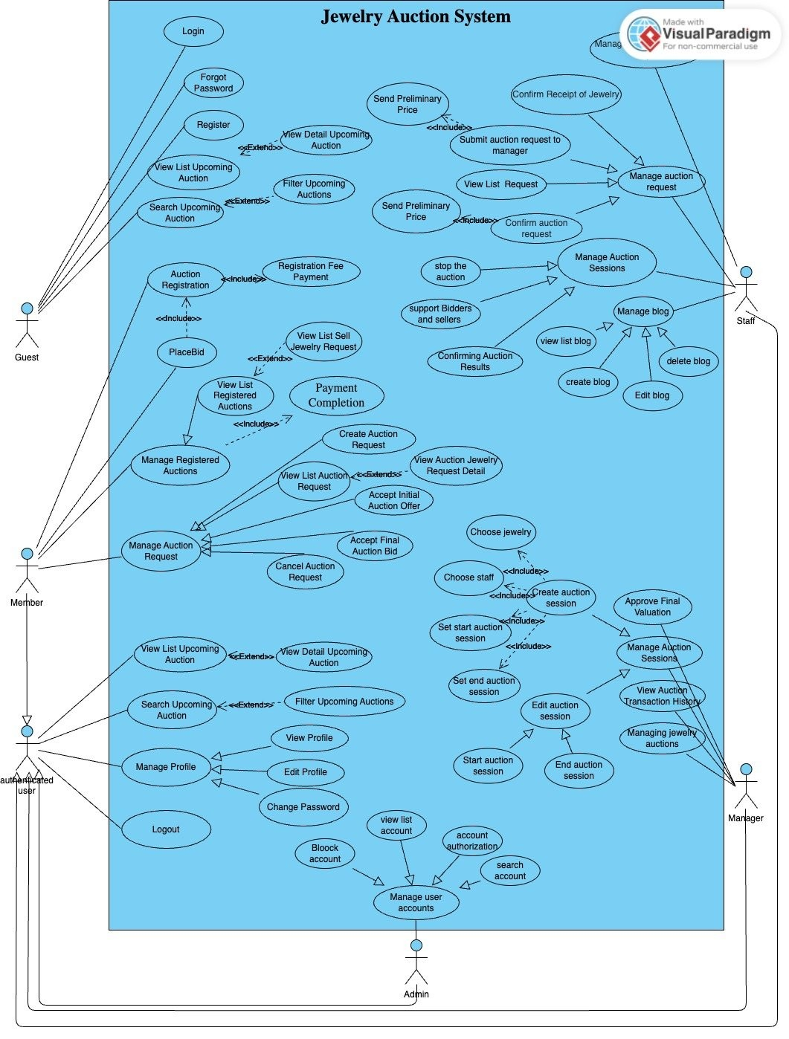

**Use Case List**

| **Use Case No.** | **Use Case Name** | **Priority** | **Actors** | **Description** |
| --- | --- | --- | --- | --- |
| *UC001* | Login | High | Guest, Member, Staff, Manager, Admin | This use case describes how a user logs into the system. |
| *UC002* | Forgot Password | Normal | Guest, Member, Staff, Manager, Admin | This use case describes how a user resets their password. |
| *UC003* | Register | High | Guest | This use case describes how a guest registers for a new account. |
| *UC004* | View List Upcoming Auction | Normal | Guest, Member | This use case describes how users view a list of upcoming auctions. |
| *UC005* | View Detail Upcoming Auction | Normal | Guest, Member | This use case describes how users view details of an upcoming auction. |
| *UC006* | Search Upcoming Auction | Normal | Guest, Member | This use case describes how users search for upcoming auctions. |
| *UC007* | Filter Upcoming Auctions | Normal | Guest, Member | This use case describes how users filter upcoming auctions. |
| *UC008* | Auction Registration | High | Member | This use case describes how a member registers for an auction. |
| *UC009* | Registration Fee Payment | High | Member | This use case describes how a member pays the registration fee. |
| *UC010* | Place Bid | High | Member | This use case describes how a member places a bid on an auction. |
| *UC011* | Manage Registered Auctions | High | Member | This use case describes how a member manages their registered auctions. |
| *UC012* | View List Registered Auctions | Normal | Member | This use case describes how a member views a list of their registered auctions. |
| *UC013* | View List Sell Jewelry Request | Normal | Member | This use case describes how a member views a list of jewelry requests they have submitted. |
| *UC014* | Payment Completion | High | Member | This use case describes how a member completes a payment. |
| *UC015* | Manage Auction Request | High | Member, Manager, Staff | This use case describes how auction requests are managed. |
| *UC016* | Create Auction Request | High | Member | This use case describes how a member creates an auction request. |
| *UC017* | View List Auction Request | Normal | Member | This use case describes how a member views a list of their auction requests. |
| *UC018* | View Auction Jewelry Request Detail | Normal | Member | This use case describes how a member views the details of their auction jewelry request. |
| *UC019* | Accept Initial Auction Offer | High | Member | This use case describes how a member accepts the initial auction offer. |
| *UC020* | Accept Final Auction Bid | High | Member | This use case describes how a member accepts the final auction bid. |
| *UC021* | Cancel Auction Request | Normal | Member | This use case describes how a member cancels their auction request. |
| *UC022* | View List of Upcoming Auctions | Normal | Member | This use case describes how a member views a list of upcoming auctions. |
| *UC023* | View Detail of Upcoming Auction | Normal | Member | This use case describes how a member views details of an upcoming auction. |
| *UC024* | Search Upcoming Auction | Normal | Member | This use case describes how a member searches for upcoming auctions. |
| *UC025* | Filter Upcoming Auctions | Normal | Member | This use case describes how a member filters upcoming auctions. |
| *UC026* | Manage Profile | High | Member | This use case describes how a member manages their profile. |
| *UC027* | View Profile | Normal | Member | This use case describes how a member views their profile. |
| *UC028* | Edit Profile | Normal | Member | This use case describes how a member edits their profile. |
| *UC029* | Change Password | Normal | Member | This use case describes how a member changes their password. |
| *UC030* | Logout | Normal | Member | This use case describes how a member logs out of the system. |
| *UC031* | Manage User Accounts | High | Admin | This use case describes how an admin manages user accounts. |
| *UC032* | Block Account | High | Admin | This use case describes how an admin blocks a user account. |
| *UC033* | View List of Accounts | Normal | Admin | This use case describes how an admin views a list of user accounts. |
| *UC034* | Account Authorization | High | Admin | This use case describes how an admin authorizes user accounts. |
| *UC035* | Search Account | Normal | Admin | This use case describes how an admin searches for a user account. |
| *UC036* | Managing Jewelry Auctions | High | Manager | This use case describes how a manager manages jewelry auctions. |
| *UC037* | View Auction Transaction History | Normal | Manager | This use case describes how a manager views auction transaction history. |
| *UC038* | Manage Auction Sessions | High | Manager | This use case describes how a manager manages auction sessions. |
| *UC039* | Create Auction Session | High | Manager | This use case describes how a manager creates an auction session. |
| *UC040* | Choose Jewelry | High | Manager | This use case describes how a manager chooses jewelry for an auction. |
| *UC041* | Choose Staff | High | Manager | This use case describes how a manager chooses staff for an auction. |
| *UC042* | Set Start Auction Session | High | Manager | This use case describes how a manager sets the start of an auction session. |
| *UC043* | Set End Auction Session | High | Manager | This use case describes how a manager sets the end of an auction session. |
| *UC044* | Edit Auction Session | Normal | Manager | This use case describes how a manager edits an auction session. |
| *UC045* | Start Auction Session | High | Manager | This use case describes how a manager starts an auction session. |
| *UC046* | End Auction Session | High | Manager | This use case describes how a manager ends an auction session. |
| *UC047* | Approve Final Valuation | High | Manager | This use case describes how a manager approves the final valuation. |
| *UC048* | Manage Blog | Normal | Manager, Staff | This use case describes how blogs are managed. |
| *UC049* | View List of Blogs | Normal | Manager, Staff | This use case describes how users view a list of blogs. |
| *UC050* | Create Blog | Normal | Manager, Staff | This use case describes how a user creates a blog. |
| *UC051* | Edit Blog | Normal | Manager, Staff | This use case describes how a user edits a blog. |
| *UC052* | Delete Blog | Normal | Manager, Staff | This use case describes how a user deletes a blog. |
| *UC053* | Manage Auction Sessions | High | Staff | This use case describes how staff manage auction sessions. |
| *UC054* | Stop the Auction | High | Staff | This use case describes how staff stop an auction. |
| *UC055* | Support Bidders and Sellers | High | Staff | This use case describes how staff support bidders and sellers. |
| *UC056* | Confirming Auction Results | High | Staff | This use case describes how staff confirm auction results. |
| *UC057* | Manage Auction Request | High | Staff | This use case describes how staff manage auction requests. |
| *UC058* | Confirm Receipt of Jewelry | High | Staff | This use case describes how staff confirm receipt of jewelry. |
| *UC059* | Submit Auction Request to Manager | High | Staff | This use case describes how staff submit auction requests to the manager. |
| *UC060* | Send Preliminary Price | Normal | Staff | This use case describes how staff send preliminary prices. |
| *UC061* | View List Requests | Normal | Staff | This use case describes how staff view a list of requests. |
| *UC062* | Confirm Auction Request | High | Staff | This use case describes how staff confirm auction requests. |
| *UC063* | Send Preliminary Price | Normal | Staff | This use case describes how staff send preliminary prices. |
| *UC064* | Manage Deliver Jewelry to Buyer | High | Staff | This use case describes how staff manage delivery of jewelry to the buyer. |

4. UI (FRONTEND) (quang)

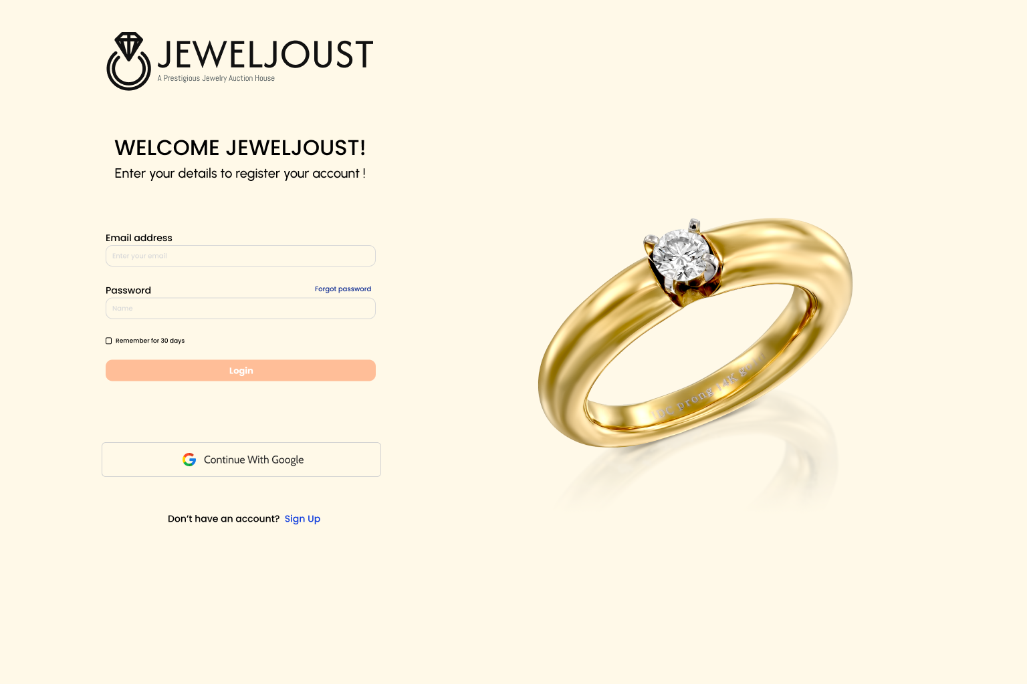

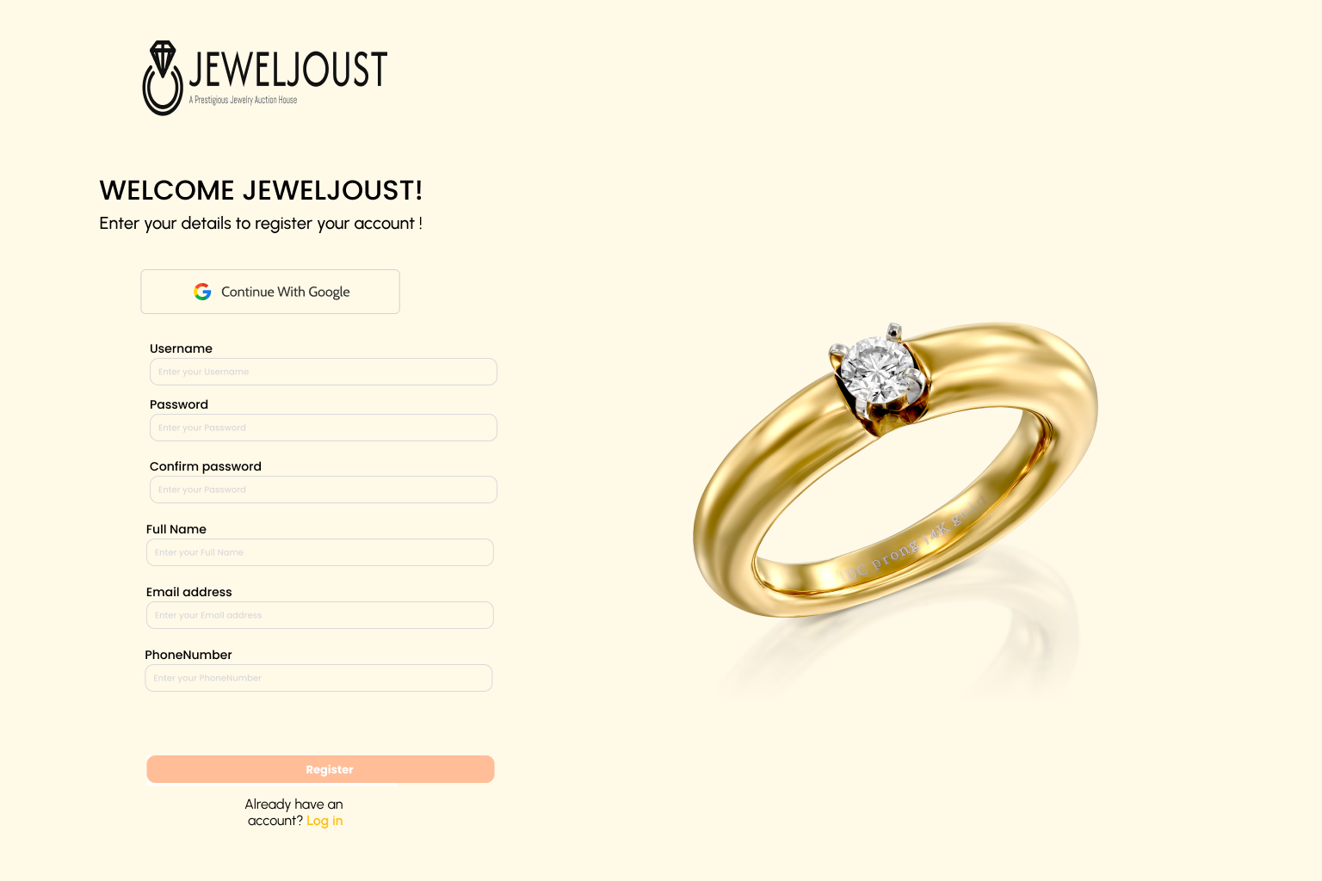

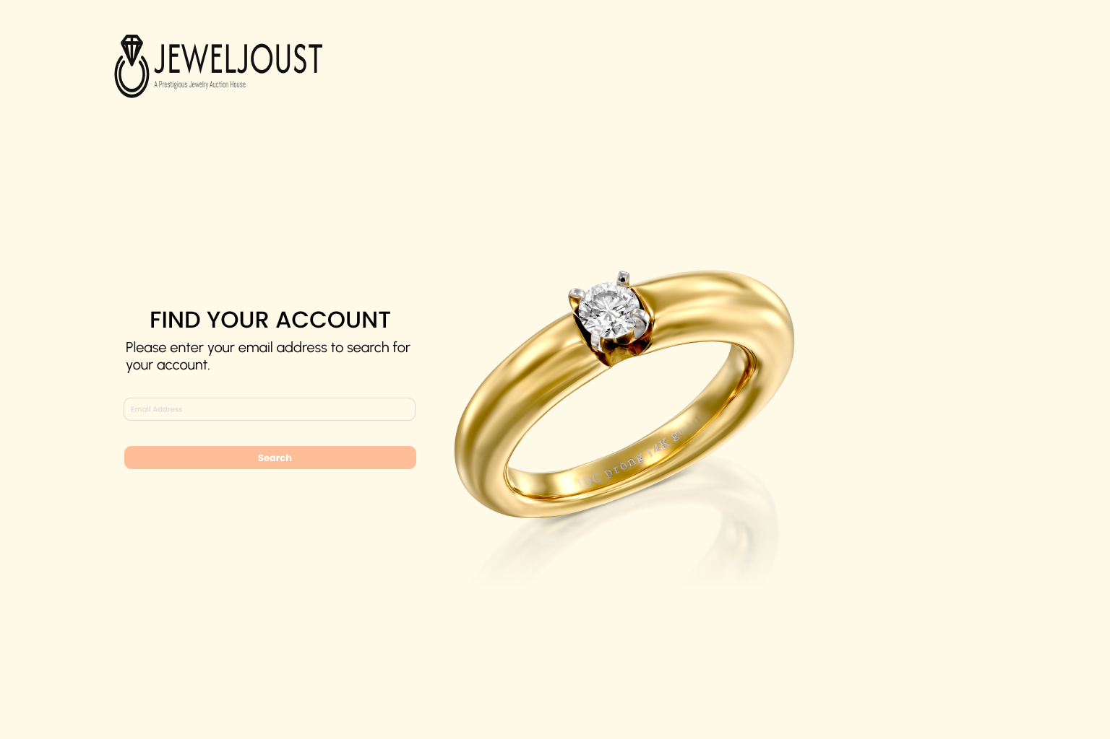

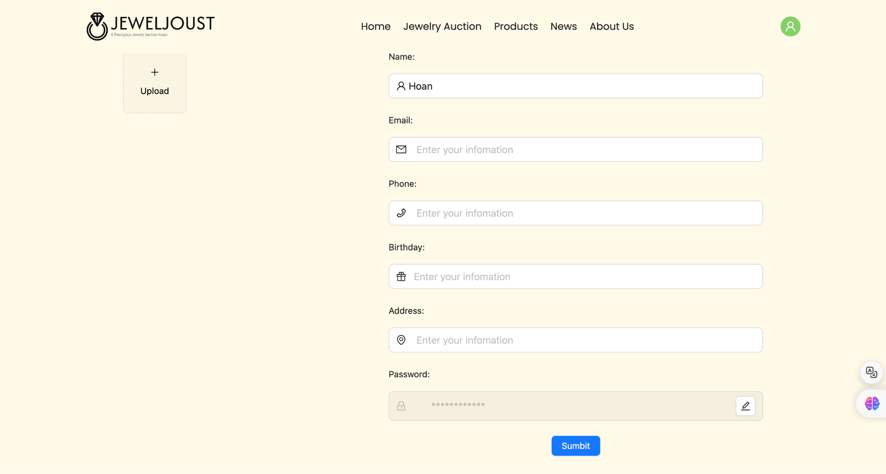

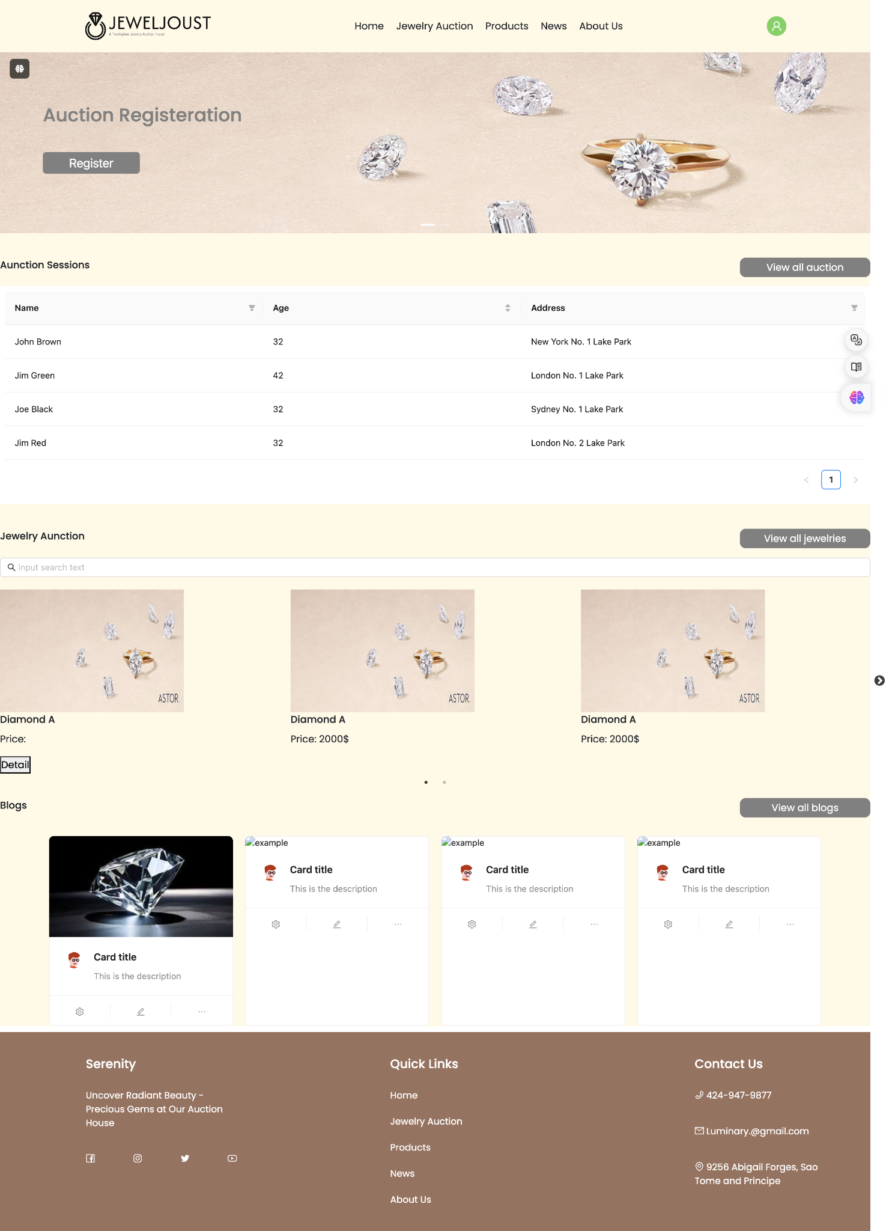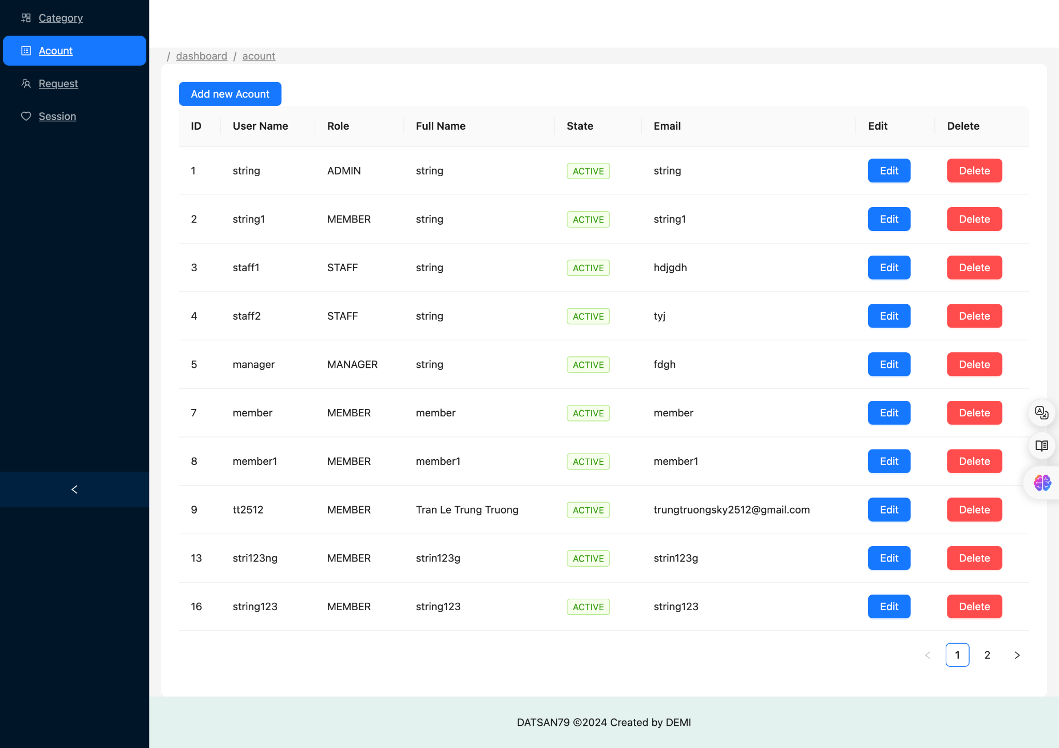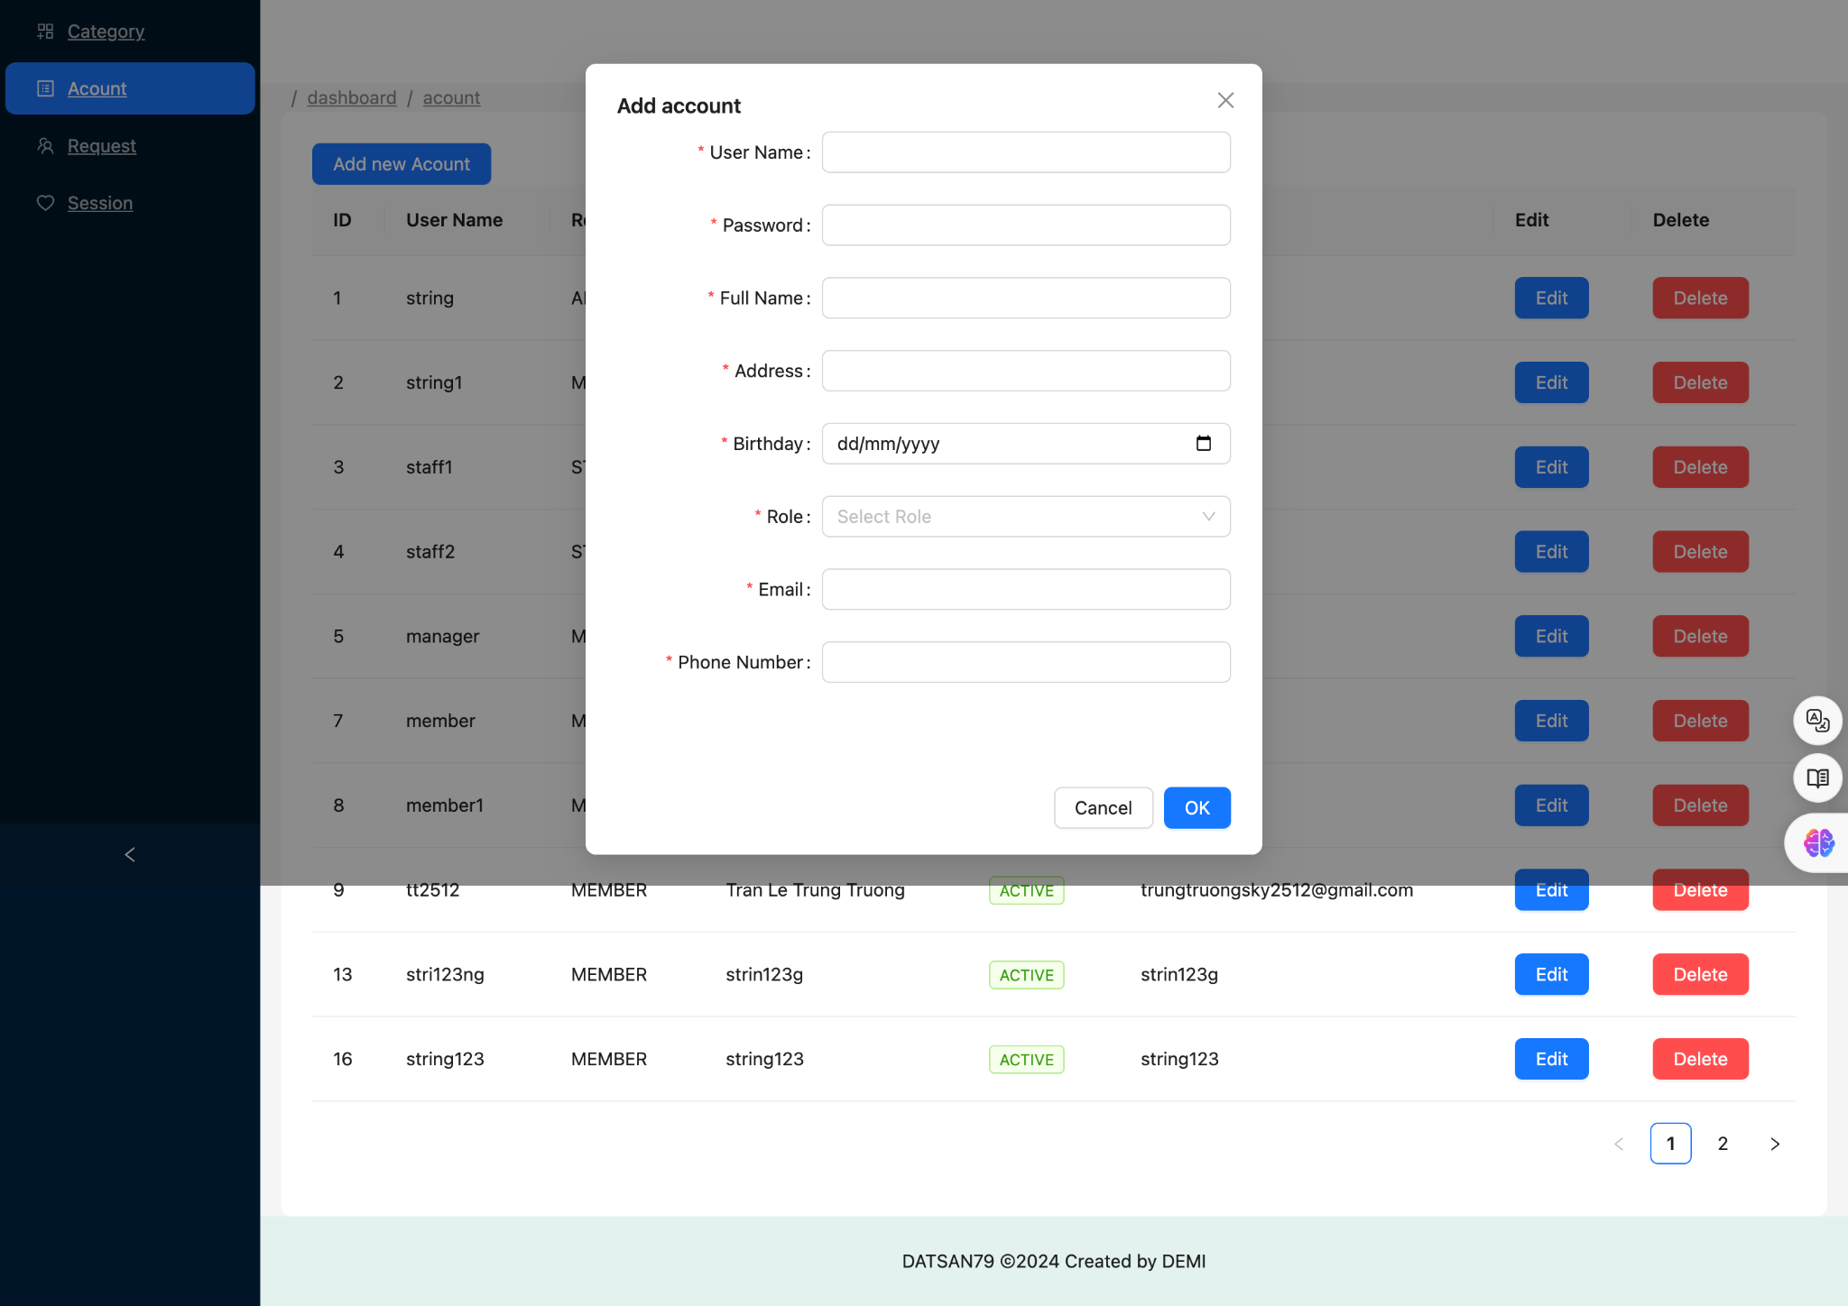

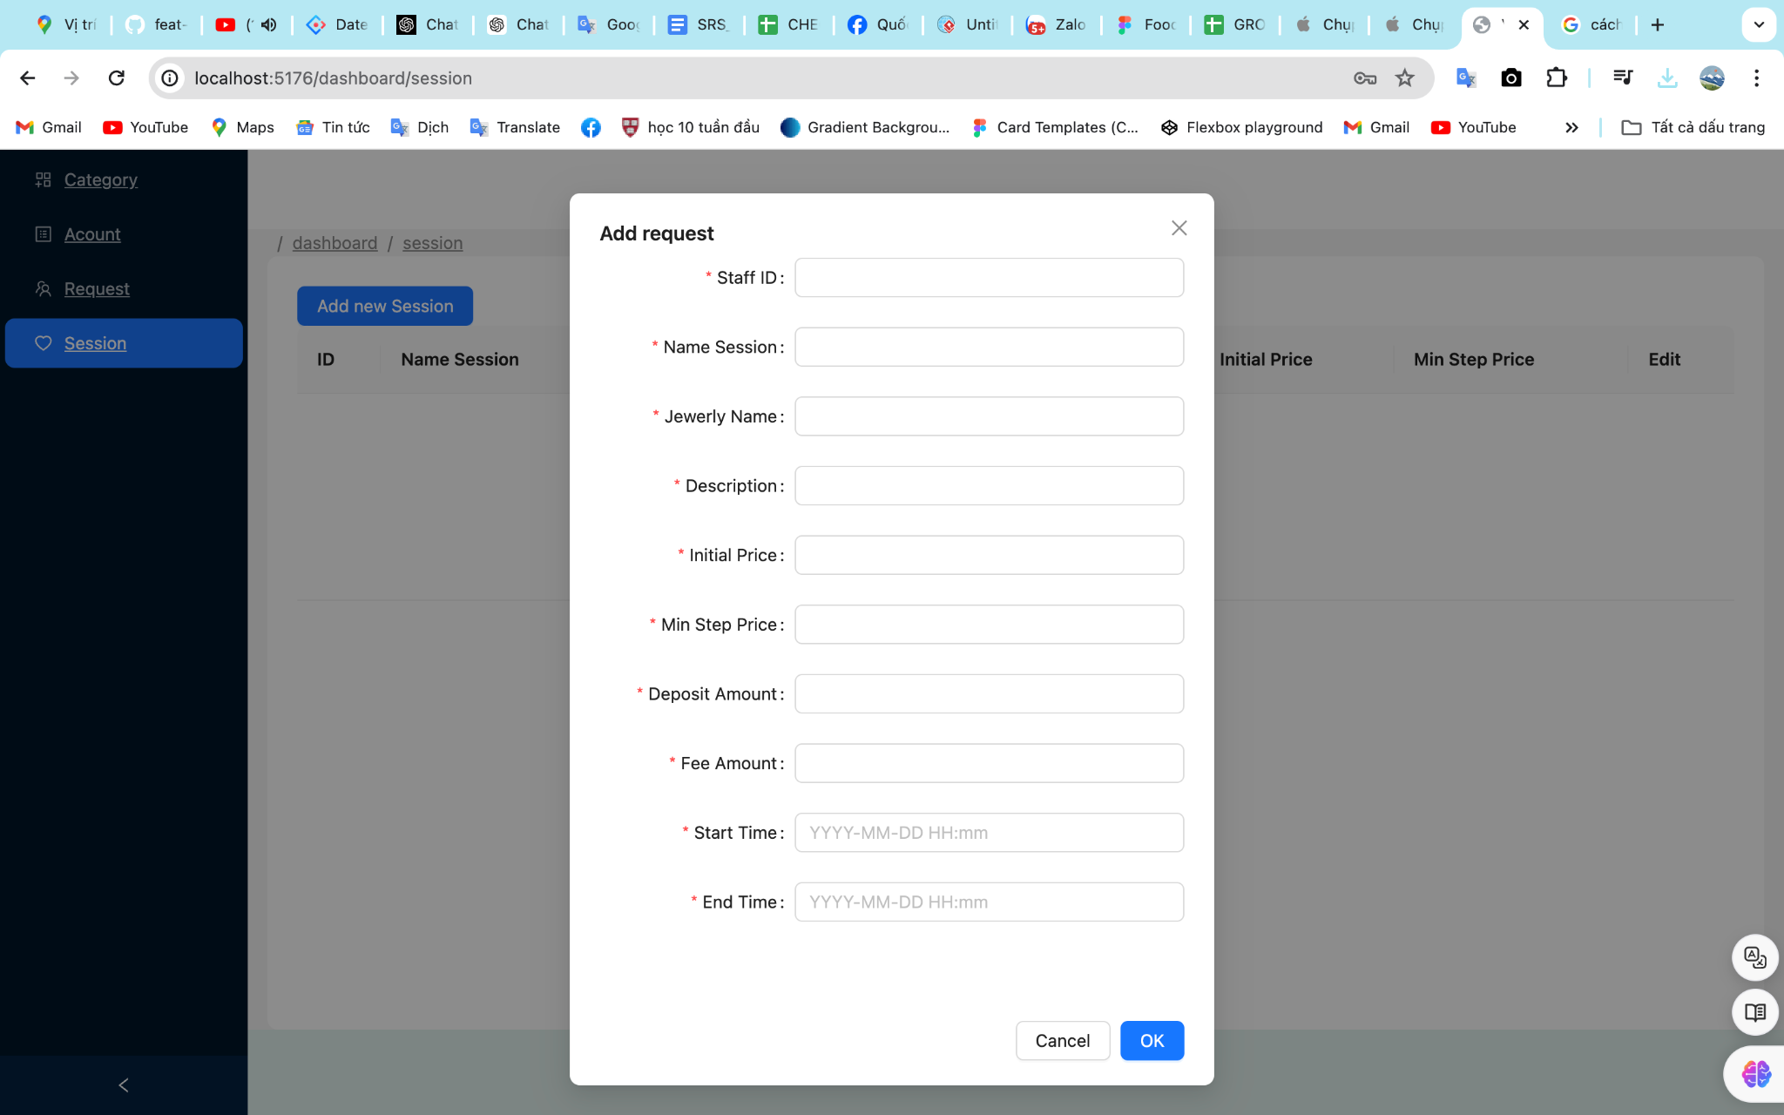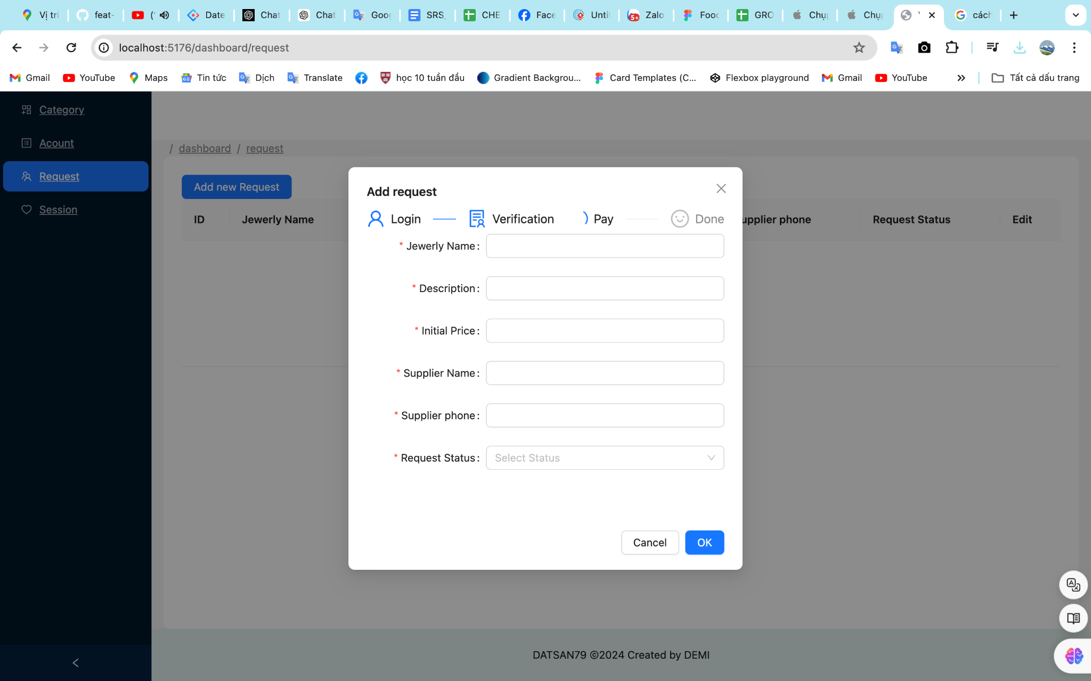

5. TECHNICAL REQUIREMENT

### **1. Functional Requirements**

#### **1.1. Homepage**

* The system must have a homepage introducing the auction company.
* The homepage must display a list of jewelry items currently up for auction.
* Provide information about company policies and regulations.
* Include a blog sharing news and related information.

#### **1.2. Search and Auction**

* Buyers must be able to search for jewelry items through a search bar.
* Buyers must be able to view jewelry details and place bids.

#### **1.3. Manage Jewelry Auction Requests from Sellers**

* Sellers submit auction requests for their jewelry.
* Staff sends a preliminary valuation to the seller and requests the jewelry to be sent to the company.
* Staff confirms receipt of the jewelry.
* Staff sends the final valuation to the manager for approval.
* The manager approves the final valuation.
* Staff sends the final valuation to the seller.
* The seller confirms acceptance of the auction.
* The manager assigns the jewelry to an auction session.

#### **1.4. Manage Jewelry Auction Process for Buyers**

* Buyers register to participate in auctions.
* Buyers place bids before the auction session starts.
* The system selects the highest pre-auction bid to start the auction session.
* Buyers participate in the live auction.
* The system notifies buyers of the auction result (win or lose) at the end of the session.
* Buyers make payments for won items.
* Staff hands over the jewelry to the buyer.
* The system transfers money to the seller.

#### **1.5. Auction Session Management**

* Create auction sessions.
* Select jewelry items to be included in the session.
* Assign staff to manage the auction.
* Open and close auction sessions.
* Pause auction sessions.
* View transaction history for auction sessions.

#### **1.6. Manage Jewelry Items for Auction**

* Manage jewelry items participating in the auction.

#### **1.7. Transaction Fee Declaration**

* Declare transaction fees that buyers and sellers must pay to the company.

#### **1.8. Dashboard and Statistics**

* Provide a dashboard for statistics and reporting.

### **2. Non-functional Requirements**

#### **2.1. Performance**

* The system must handle at least 1,000 requests per second.
* The response time for user actions must be under 2 seconds.

#### **2.2. Security**

* Data encryption for sensitive information (e.g., user credentials, payment information).
* Multi-factor authentication for users.
* Role-based access control to restrict access to sensitive functionalities.

#### **2.3. Usability**

* The system must be user-friendly and intuitive.
* Provide clear instructions and feedback for user actions.

#### **2.4. Reliability**

* The system must have 99.9% uptime.
* Backup and recovery procedures must be in place.

#### **2.5. Compatibility**

* The system must be compatible with major web browsers (Chrome, Firefox, Safari, Edge).
* Must be accessible on both desktop and mobile devices.

### **3. Interface Requirements**

* User interface must be responsive and adaptive to different screen sizes.
* Provide API endpoints for integration with third-party services (e.g., payment gateways, shipping services).

### **4. Maintainability Requirements**

* Code must be well-documented and follow industry standards.
* The system should support easy updates and maintenance.

### **5. Scalability Requirements**

* The system must be scalable to handle increased traffic and data volume in the future.
* Support for load balancing to distribute traffic effectively.

### **6. Compliance Requirements**

* Ensure compliance with relevant data protection regulations (e.g., GDPR, CCPA).
* Maintain audit logs for all transactions and actions performed within the system.

These technical requirements ensure that the online jewelry auction management software is functional, secure, and efficient, meeting both business needs and user expectations.

6. SCREEN FLOW(quang)

**Login**

Home page (click login link ) → login page ( input username and password ) → home page

( dont’t have login link and have avata ):

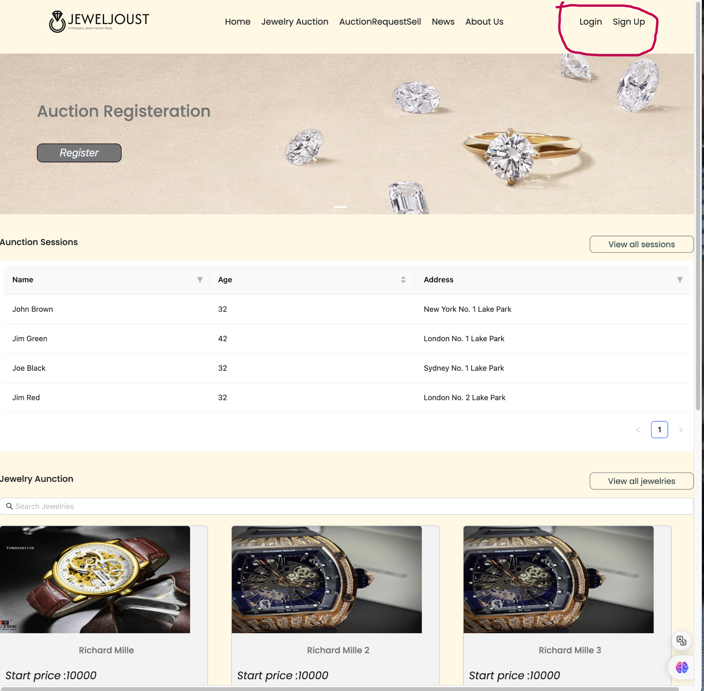

next page:

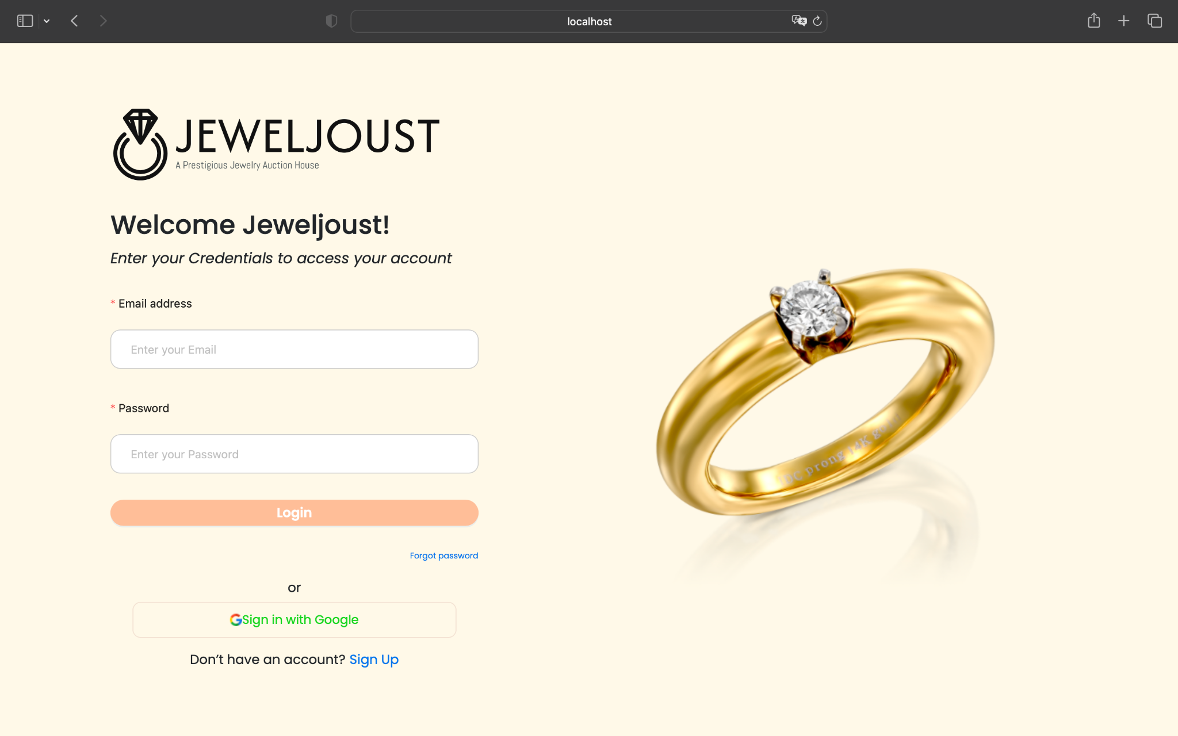

Next page:

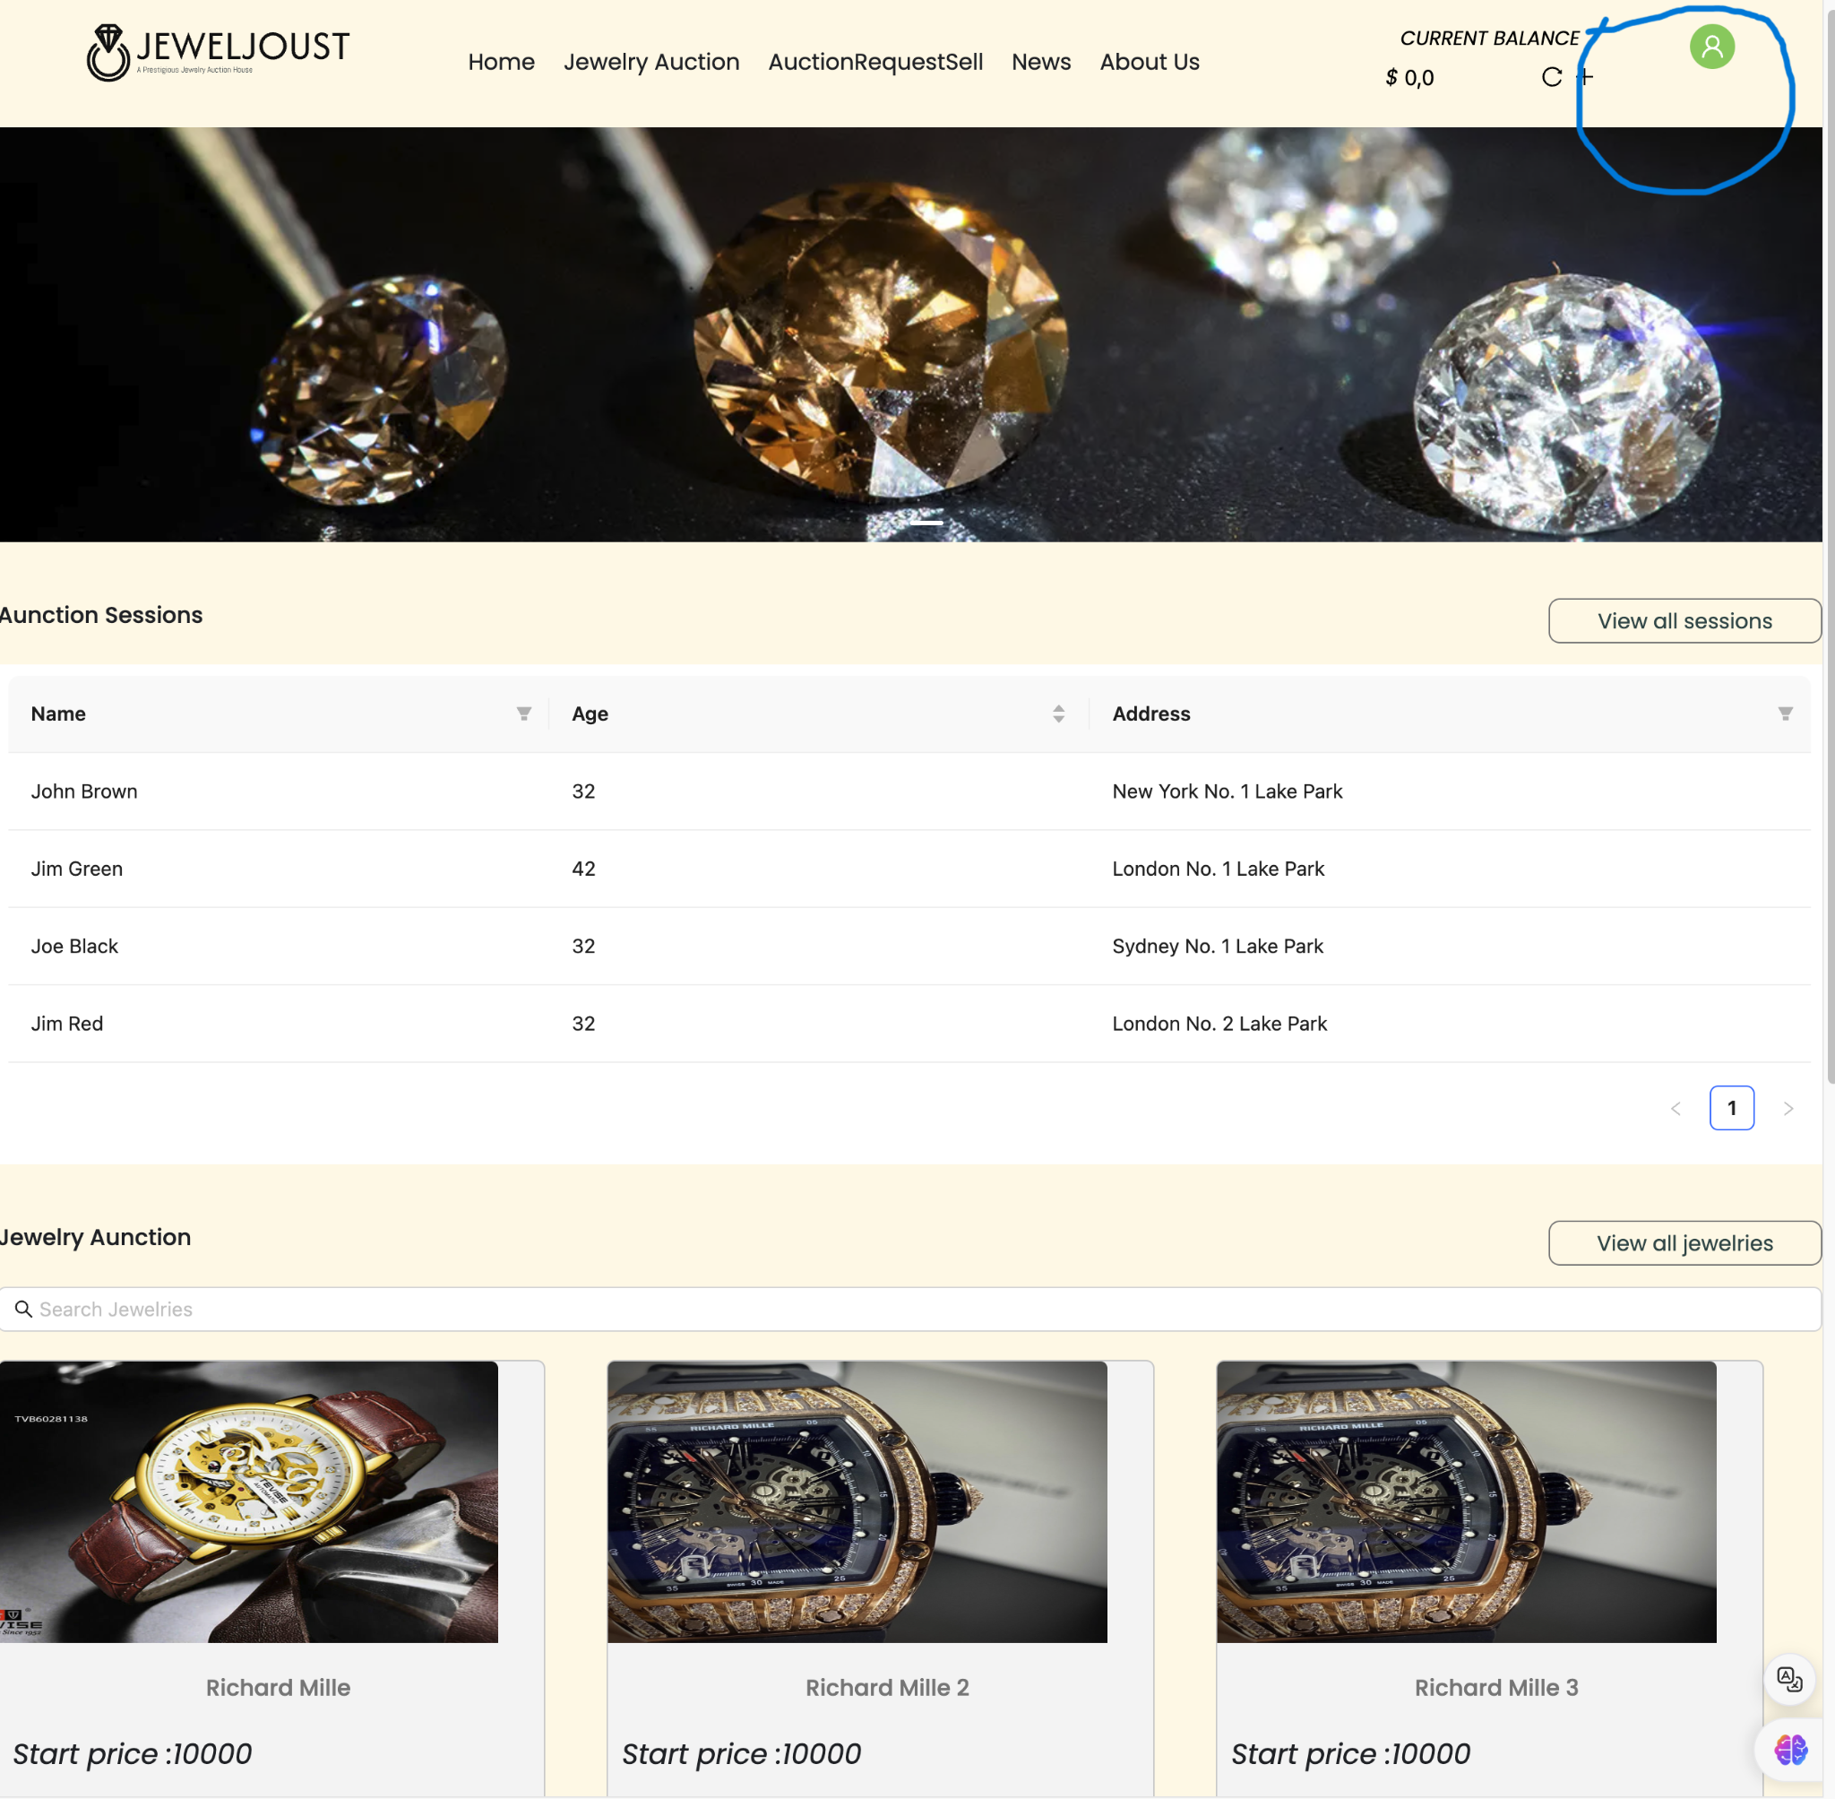

**Register**

Home page (click register link ) → login page ( input information ) → login page ( input username and password ) → home page ( dont’t have register link and have avata ):



Next page:

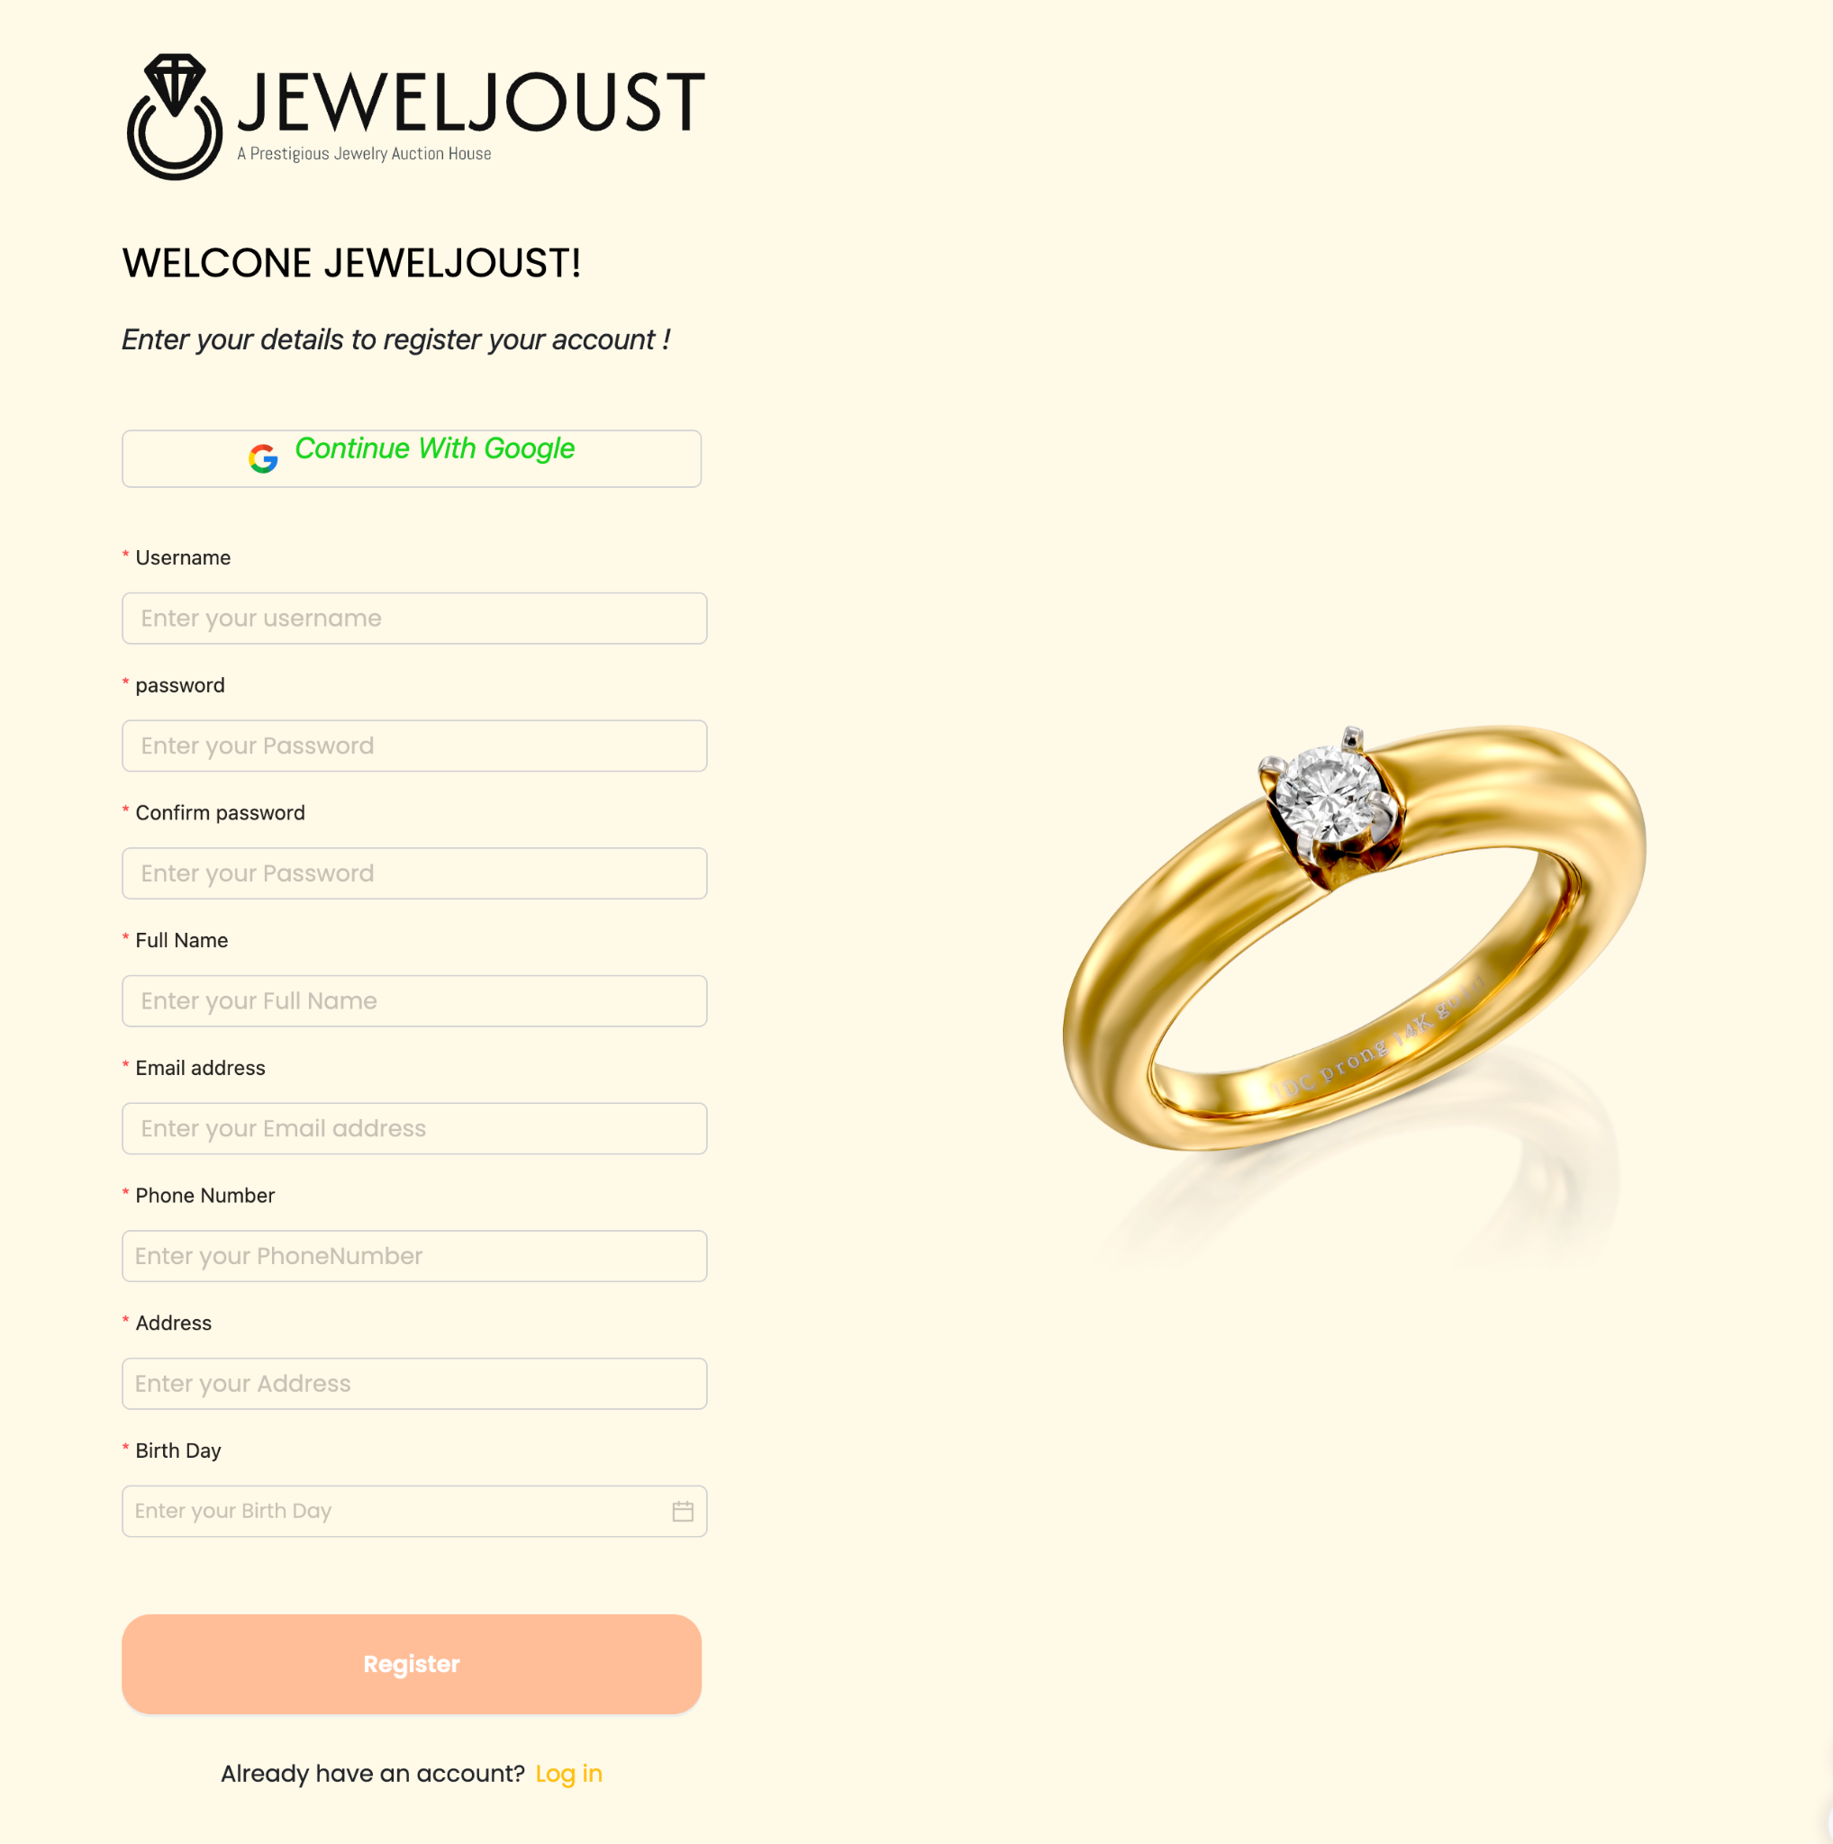

Next page:



Next page:



**Create Request**

Home page (click create request link ) → create request page ( input information and upload image ) → home page :

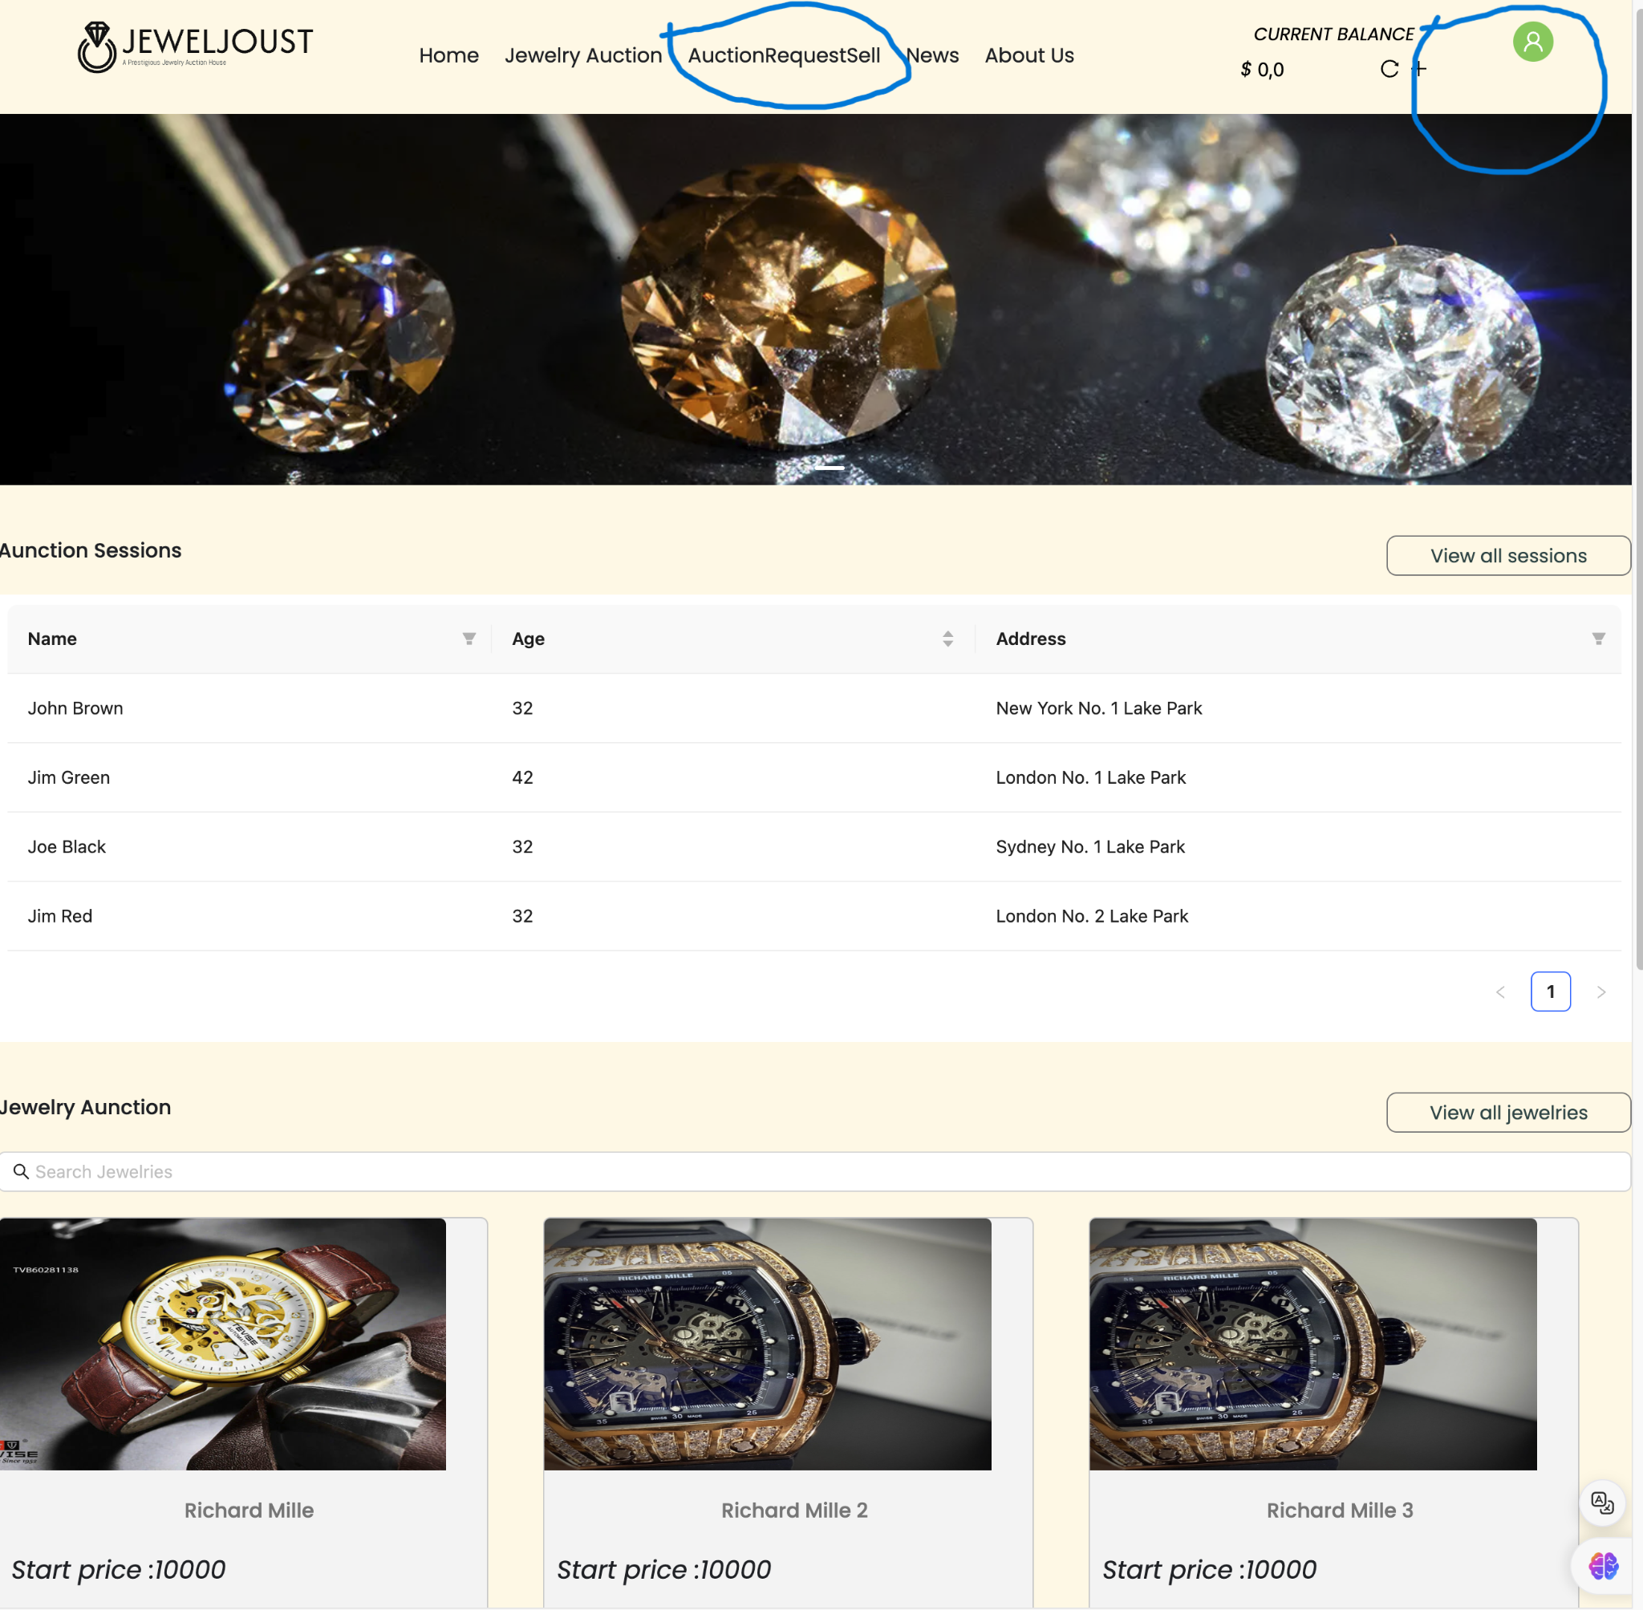

Next page:

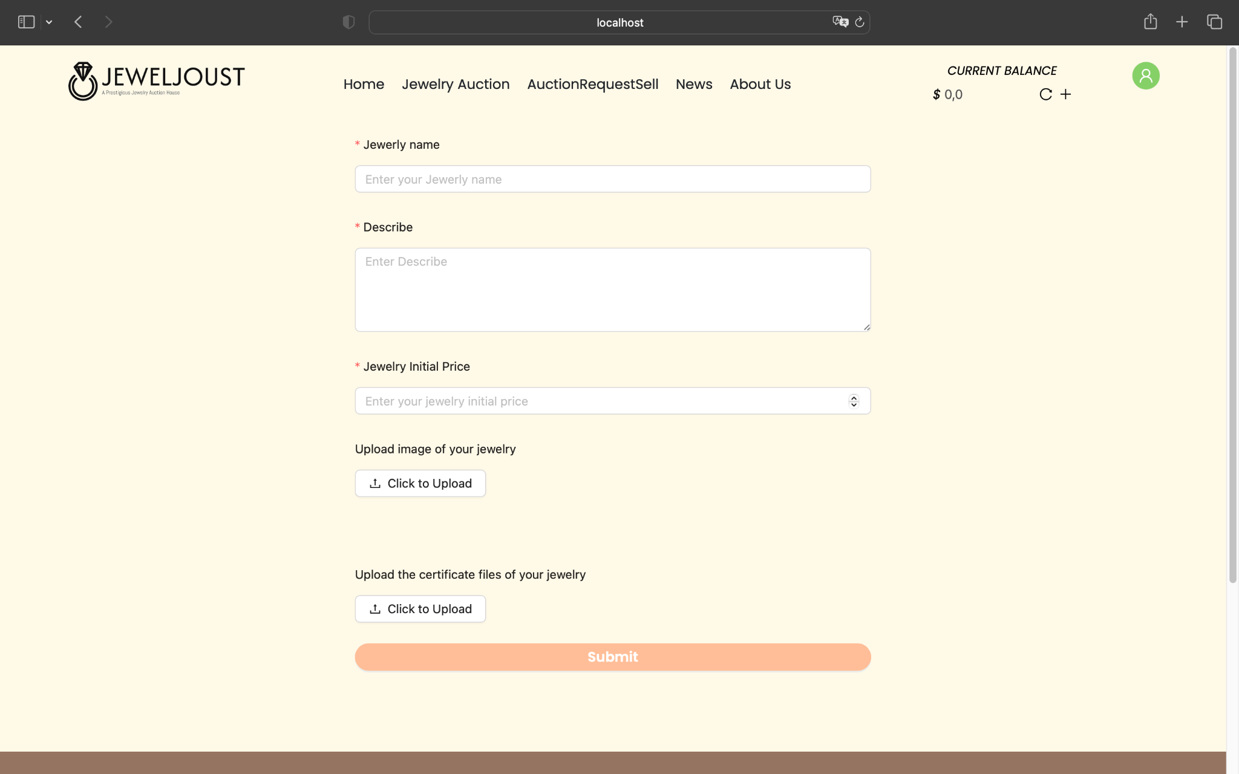

Next page:

 **Manage Account**

Dashboard page (click manage account link ) → manage account page ( click add new account button ) → mini add page ( input information to add and click ok button to submit) → manage account page ( click edit acout button )--> mini add page ( input information to edit and click ok button to submit) → manage account page ( have new list account click delete account button ) → manage account page ( have new list account )

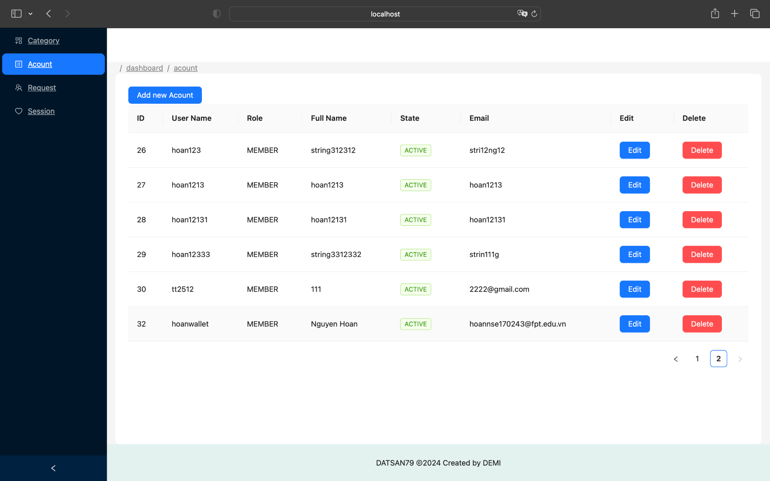

Next page :

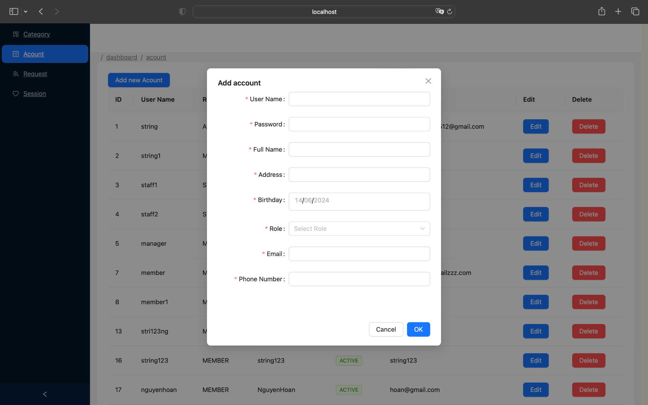

Next page :



Next page :

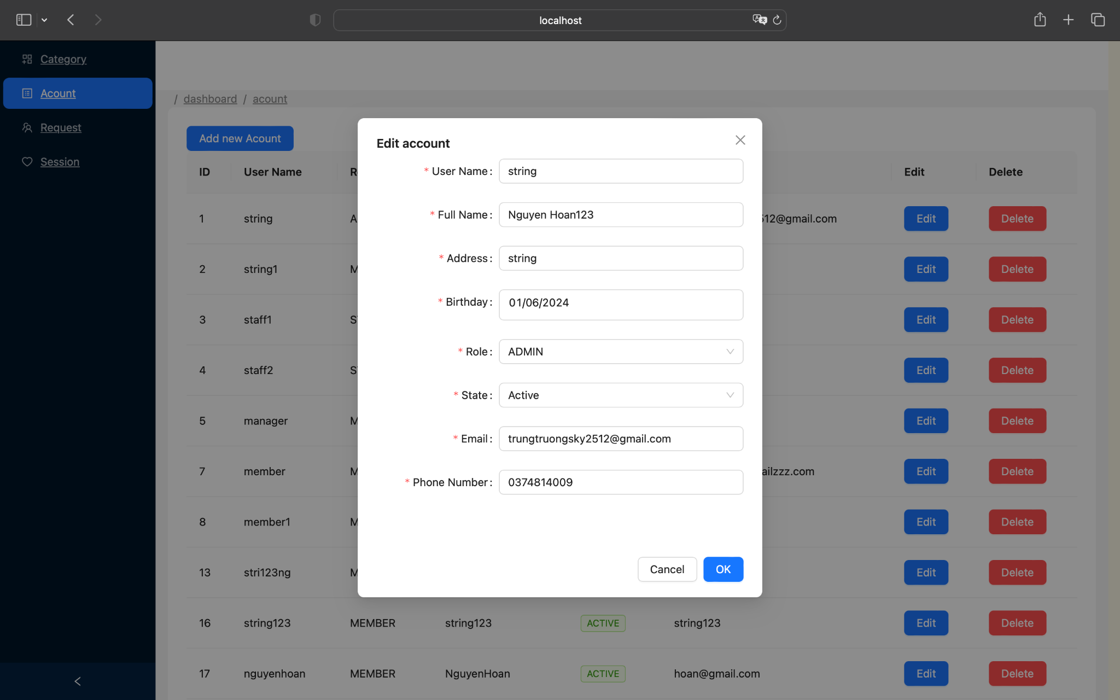

Next page :

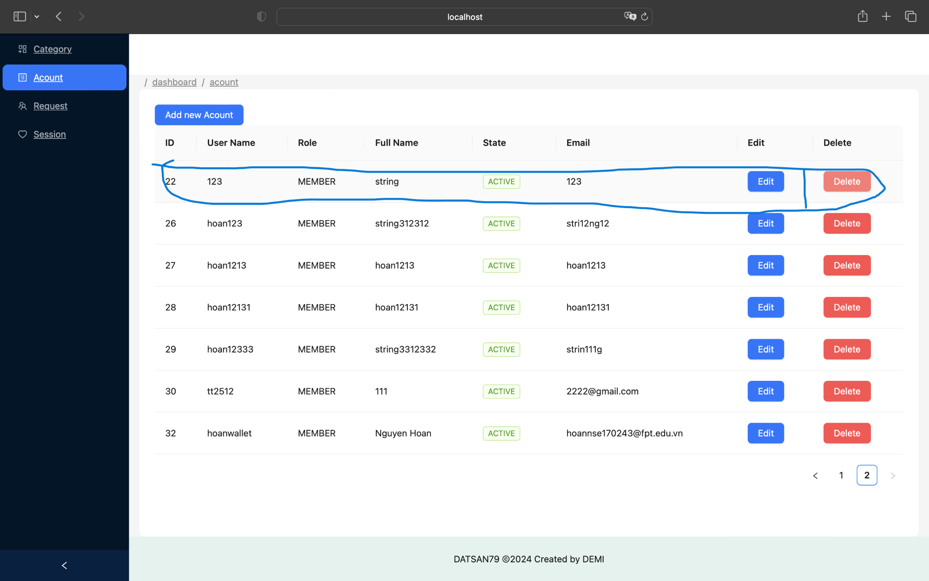

Next page :



**Manage Request**

Dashboard page (click manage request link ) → manage request page ( click edit request button ) → mini edit page ( input information to edit and click ok button to submit) → manage request page ( have new list request )

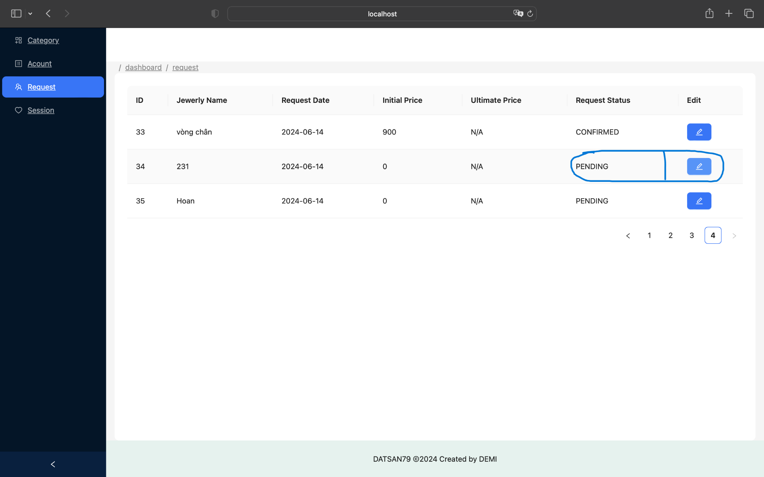

Next page :

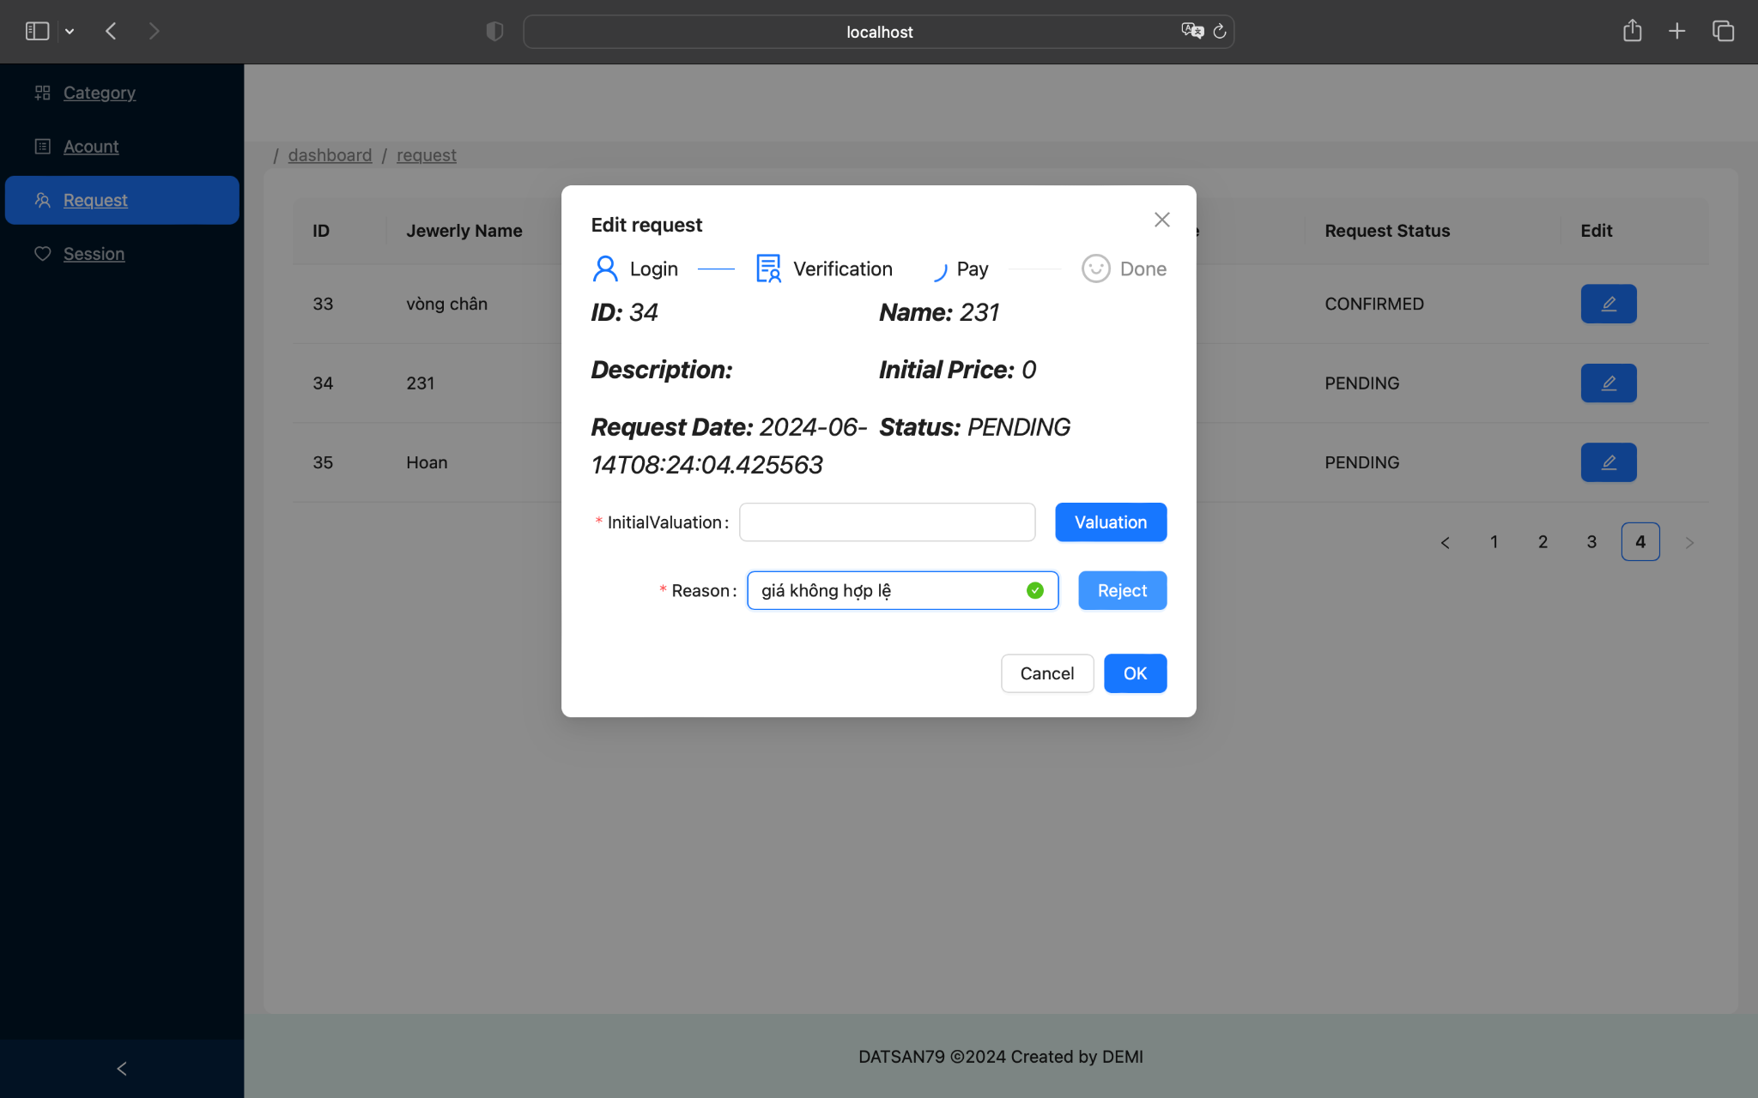

Next page :

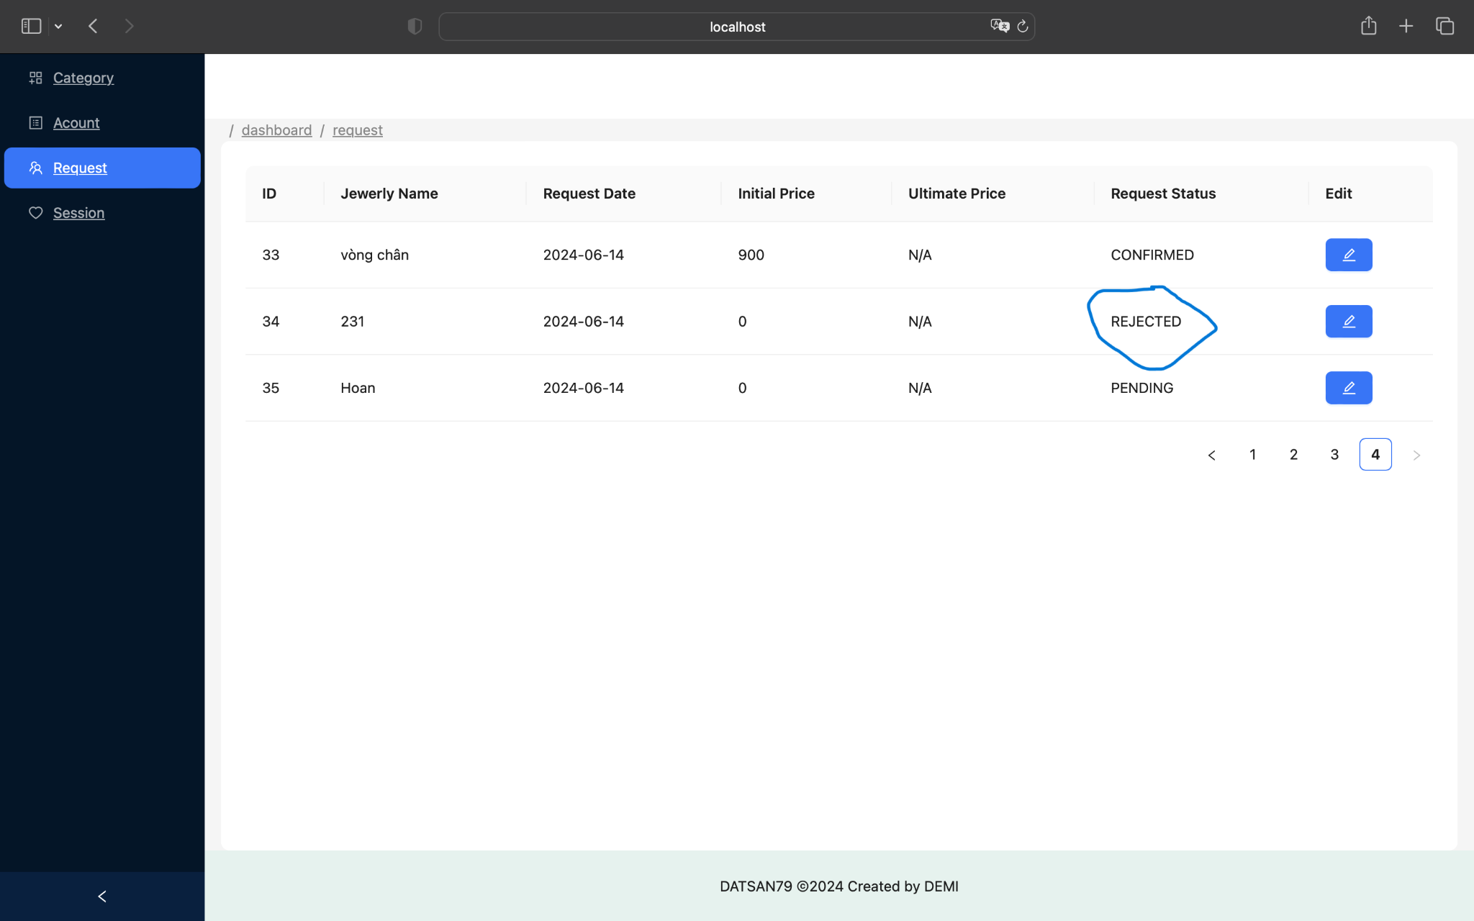

**Manage Session**

Dashboard page (click manage session link ) → manage session page ( click add new session button ) → mini add page ( input information to add and click ok button to submit) → manage session page ( click edit session button )--> mini edit page ( input information to edit and click ok button to submit) → manage session page ( have new list session click )

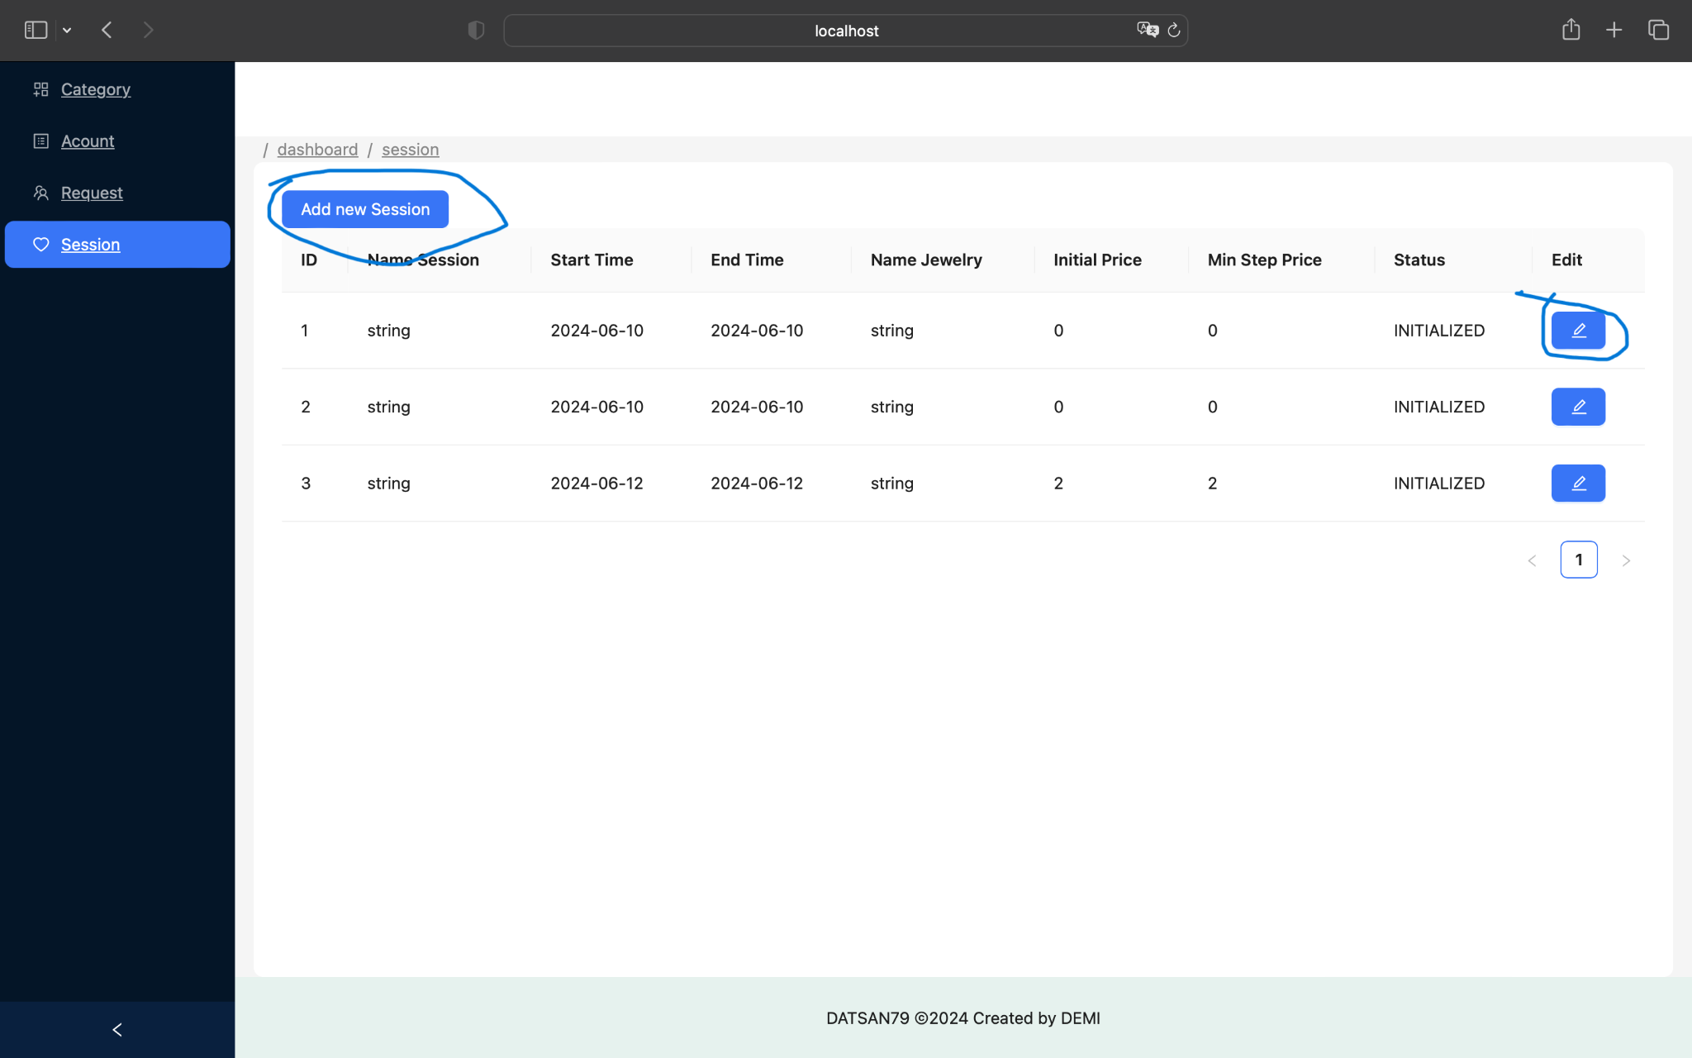

Next page :

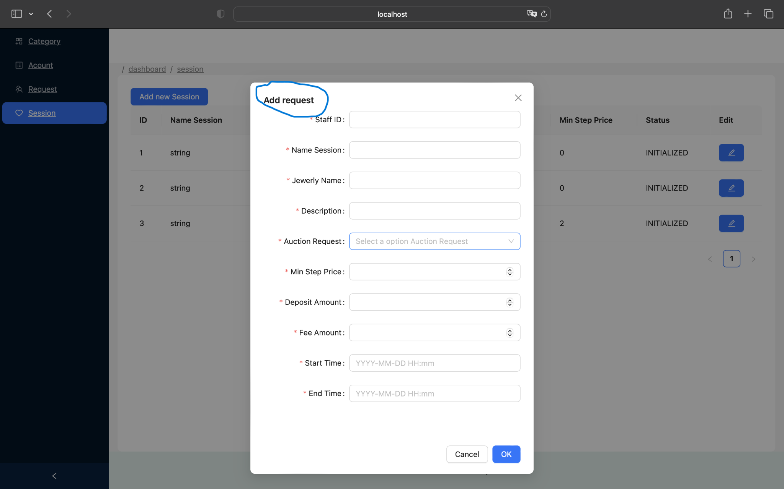

Next page :



Next page :

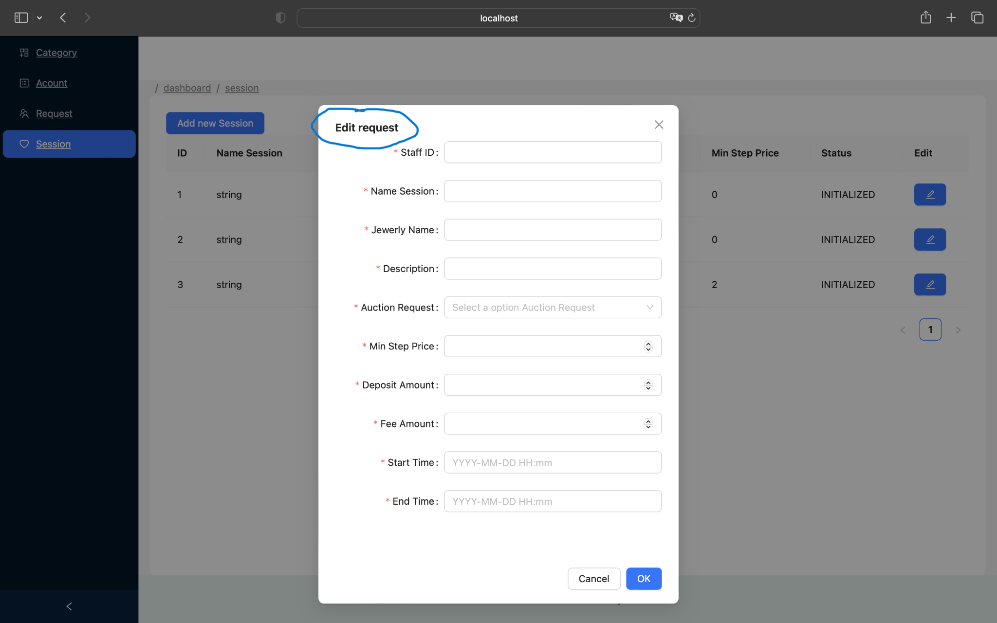

Next page :

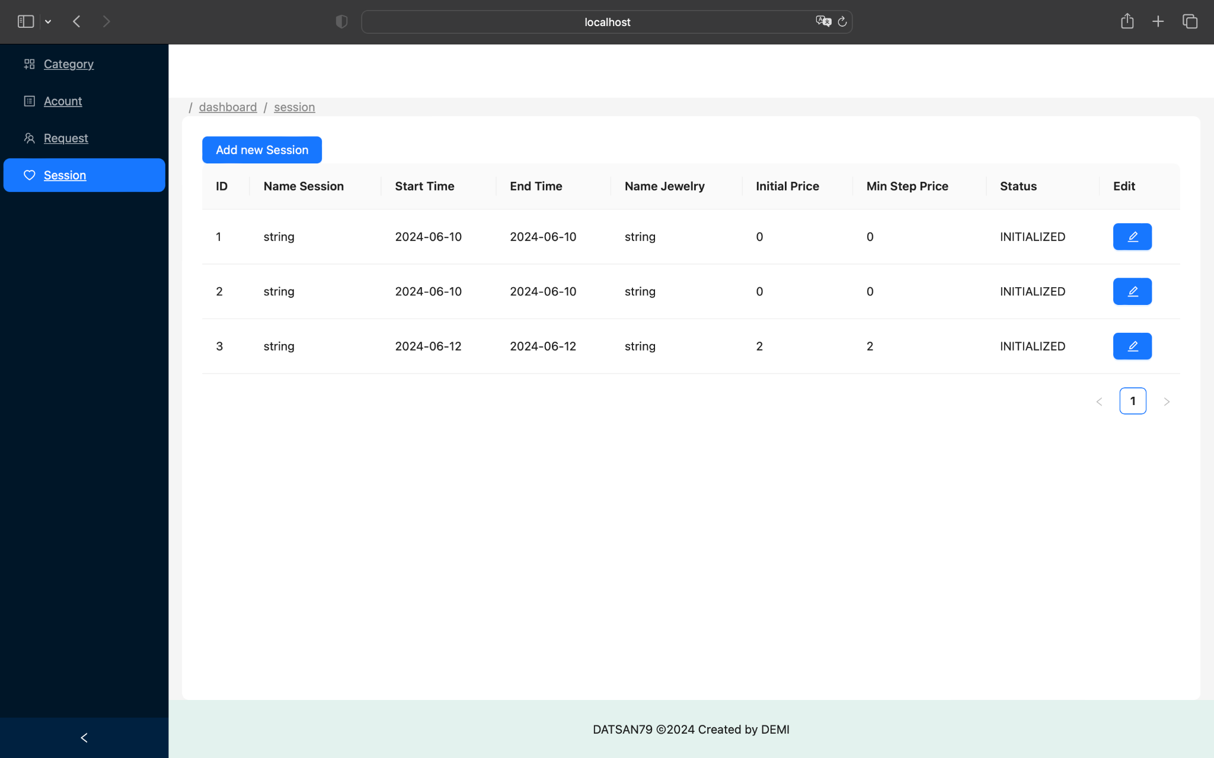

7. BUSSINESS RULE(Trường)

#### **Homepage**

* Introduction of the auction company, auctioned jewelry, policies, blog.

#### **Buyer Functions**

* Search and browse jewelry information for auctions.

#### **Seller Auction Request Management**

1. Seller submits auction request.
2. Staff sends preliminary valuation and requests jewelry.
3. Staff confirms receipt of jewelry.
4. Staff sends final valuation to the manager.
5. Manager approves the final valuation.
6. Staff sends the approved valuation to the seller.
7. Seller confirms acceptance of auction.
8. Manager assigns auction session for the jewelry.

#### **Buyer Auction Process Management**

1. Buyer registers for the auction.
2. Buyer places bids before the auction starts.
3. System selects the highest pre-auction bid as the starting bid.
4. Buyers participate in the live auction.
5. System announces auction results.
6. Winning buyer makes payment.
7. Staff delivers jewelry to the buyer.
8. System transfers payment to the seller.

#### **Auction Session Management**

* Create sessions, select jewelry, assign staff, open/close/pause sessions, record transaction history.

#### **Jewelry Management**

* Manage jewelry participating in auctions.

#### **Transaction Fees**

* Declare transaction fees for buyers/sellers.

#### **Dashboard and Statistics**

* Provide auction data statistics and analysis.

User Story   
**1. Homepage**

1. **As a visitor, I want to see an introduction to the auction company on the homepage, so I can learn more about the company.**
2. **As a visitor, I want to see a list of jewelry items currently up for auction on the homepage, so I can quickly find items of interest.**
3. **As a visitor, I want to read about the company’s policies and regulations, so I understand how the auction process works.**
4. **As a visitor, I want to access a blog with news and related information, so I can stay informed about the latest updates and insights.**

#### **2. Search and Auction**

1. **As a buyer, I want to search for jewelry items using a search bar, so I can find specific items quickly.**
2. **As a buyer, I want to view detailed information about a jewelry item, so I can make informed bidding decisions.**
3. **As a buyer, I want to place bids on jewelry items, so I can participate in auctions.**

#### **3. Manage Jewelry Auction Requests from Sellers**

1. **As a seller, I want to submit an auction request for my jewelry, so I can sell my items through the auction platform.**
2. **As a staff member, I want to send a preliminary valuation to the seller, so they can decide whether to send the jewelry to the company.**
3. **As a staff member, I want to confirm receipt of the jewelry, so we can proceed with the final valuation.**
4. **As a staff member, I want to send the final valuation to the manager for approval, so the valuation process is complete.**
5. **As a manager, I want to approve the final valuation, so the jewelry can be prepared for auction.**
6. **As a staff member, I want to send the approved final valuation to the seller, so they are informed of the auction price.**
7. **As a seller, I want to confirm acceptance of the auction, so my jewelry can be listed for auction.**
8. **As a manager, I want to assign the jewelry to an auction session, so it can be included in the next available auction.**

#### **4. Manage Jewelry Auction Process for Buyers**

1. **As a buyer, I want to register to participate in auctions, so I can place bids on items.**
2. **As a buyer, I want to place bids before the auction session starts, so I can potentially secure an item at my desired price.**
3. **As a system, I want to select the highest pre-auction bid to start the auction session, so the auction begins with a competitive price.**
4. **As a buyer, I want to participate in live auctions, so I can bid on items in real-time.**
5. **As a system, I want to notify buyers of the auction result (win or lose) at the end of the session, so they are informed of the outcome.**
6. **As a buyer, I want to make payments for won items, so I can complete the purchase.**
7. **As a staff member, I want to hand over the jewelry to the buyer, so they receive their purchased items.**
8. **As a system, I want to transfer money to the seller after the buyer completes payment, so the seller receives their earnings.**

#### **5. Auction Session Management**

1. **As a manager, I want to create auction sessions, so there are structured events for selling jewelry.**
2. **As a manager, I want to select jewelry items for each session, so I can organize the items to be auctioned.**
3. **As a manager, I want to assign staff to manage the auction, so the session is well-organized and supervised.**
4. **As a manager, I want to open and close auction sessions, so I can control the timing of the auctions.**
5. **As a manager, I want to pause auction sessions if necessary, so any issues can be addressed.**
6. **As a manager, I want to view the transaction history for each auction session, so I can review and analyze the auction outcomes.**

#### **6. Manage Jewelry Items for Auction**

1. **As a staff member, I want to manage jewelry items participating in the auction, so I can keep track of the inventory.**

#### **7. Transaction Fee Declaration**

1. **As an admin, I want to declare transaction fees that buyers and sellers must pay, so the company’s fee structure is clear and enforced.**

#### **8. Dashboard and Statistics**

1. **As a manager, I want to view a dashboard with statistics and reports, so I can monitor the performance and outcomes of the auctions.**

Note

* quang và phát và hoan
* PENDING: khi member gửi yêu cầu đấu giá thì đây là trạng thái đầu tiên (chờ xác nhận)
  + Fe: tạo ra trang để xem hình ảnh tên mô tả sản phẩm. Đồng thời tạo 2 ô để nhập reason và price để gửi xuống
* CONFIRMED: khi tiếp nhận được yêu cầu đấu giá của member thì staff xác nhận chấp nhận đơn gửi (đã xác nhận)
* REJECTED: khi tiếp nhận được yêu cầu đấu giá của member nhưng staff không đồng ý đơn gửi vì lý do nào đó (từ chối)
* CANCEL: khi member đã gửi yêu cầu đấu giá nhưng muốn hủy yêu cầu của mình (hủy bỏ)
* RECEIVED: sau khi được staff CONFIRMED, thì người dùng gửi hàng đến công ty đấu giá, và sau khi công ty nhận được hàng thì staff chuyển sang trạng thái này (đã nhận được hàng)
* MISSED: sau khi được staff CONFIRMED, thì người dùng gửi hàng đến công ty đấu giá nhưng sau 14 ngày công ty không nhận được hàng thì staff chuyển sang trạng thái này (trễ thời gian gửi hàng)
* REVIEW: sau khi nhận được hàng thì tới giai đoạn định giá cuối cùng, staff sẽ định giá lại món hàng (lên/xuống giá…), đây là trạng thái chờ được định giá
* UNACCEPTED: sau khi định giá cuối cùng nhưng hàng khi gửi đến công ty không đúng như mô tả, hư hỏng… (đã xem xét nhưng không chấp nhận)
* UNAPPROVED: sau khi định giá cuối cùng được được chấp nhận thì staff gửi lên cho manager phê duyệt nhưng sau đó manager không đồng ý phê duyệt vì giá không hợp lý… (quản lý không phê duyệt)
* APPROVED: manager đồng ý phê duyệt, thì sẽ chuyển sang trạng thái này để có thể gửi định giá cuối cùng cho member
* AGREED: sau khi được quản lý phê duyệt, member đồng ý với định giá cuối cùng thì chuyển sang trạng thái này và chờ được đấu giá (member đồng ý định giá cuối)
* DECLINED: sau khi được quản lý phê duyệt, nhưng member không đồng ý với định giá cuối cùng thì chuyển sang trạng thái này và kết thúc yêu cầu đấu giá (member không đồng ý định giá cuối)